**NEWS-G Operation**

**Background**

NEWS-G (New Experiment with Spheres – Gases) is a dark matter detector that uses a sphere filled with gas to search for ionization events. As a particle of dark matter, know as a weakly interacting massive particle or WIMP, passes through the sphere it may interact with one of the gas atoms inside the sphere. This interaction deposits energy to the atom and can ionize an electron. The sphere is designed with a metal rod in the interior that is has a potential difference of a few thousand volts relative to the sphere itself. This causes the ionized electron to drift towards the anode as shown in the diagram below:

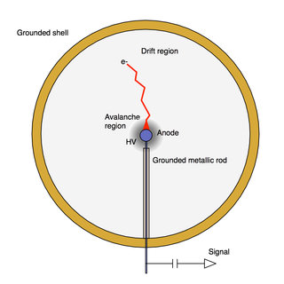

Figure 1: Diagram of NEWS-G[1]

As the electron nears the anode it gains energy causing secondary ionization of gas atoms in a Townsend Avalanche, shown in the image below (figure 2):

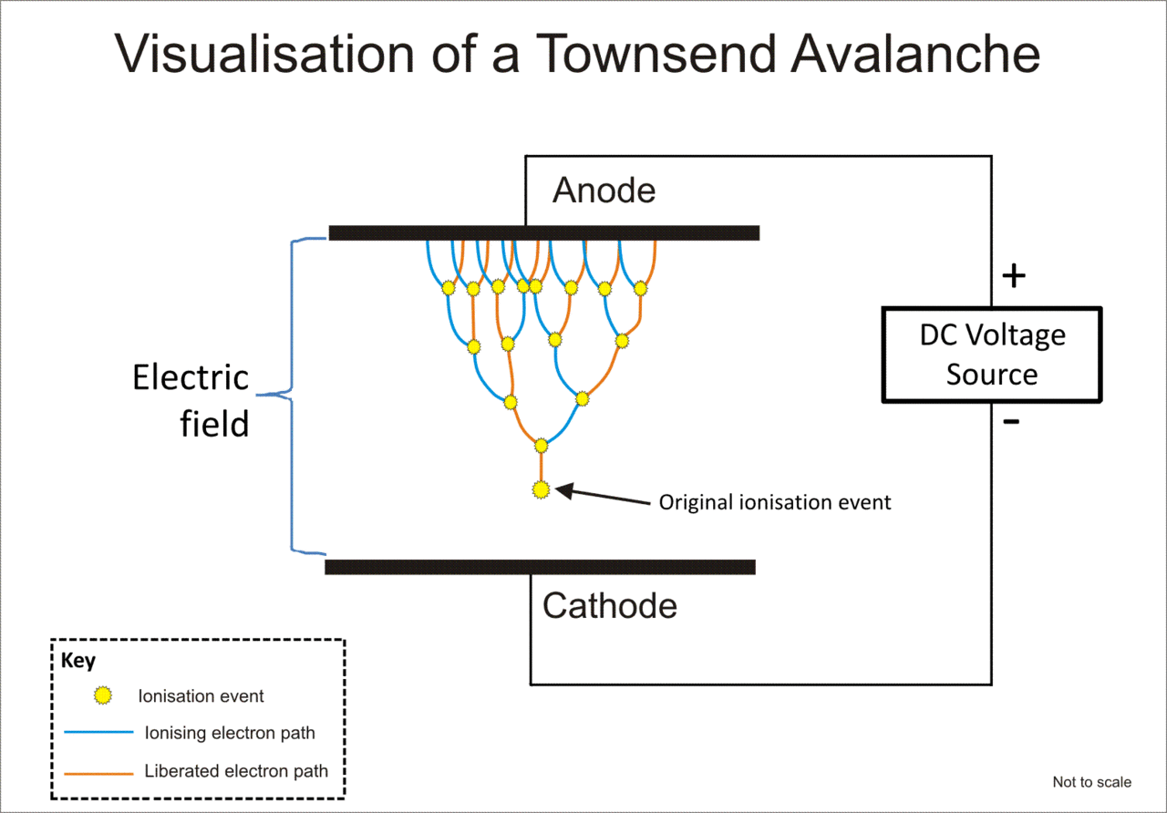

Figure : Diagram of a Townsend Avalanche[2]

For more information on NEWS-G and the experimental data it gathered visit the website below or scan the QR code.

https://news-g.org/news-snolab/



Figure 3:https://news-g.org/news-snolab/

**Activity**

1. The metal sphere is grounded while the end of the anode is given a voltage of several thousand volts. Using the diagram below, draw the electric field inside NEWS-G. *Pay special attention to the anode; the end of the anode is at several kilovolts while the outside of it is at zero volts.*

Grounding Wire

1. After ionization, and electron is produced along with a positively charged ion. Explain why the electron and the ion don’t immediately recombine despite having opposite charges.

The ionized electron is pulled towards the central anode by the electric field while the positively charged ion is pushed away.

*Use the information below to answer questions 4, 5 and 6*

In 2017, a NEWS-G experiment was run at the Laboratoire Souterrian de Modane (LSM) in France. This is an undergraound laboratory located in a tunnel between Italy and France at a depth of 2932 m. The overbearing rock acts as a shield for particles from space. One such particle is a muon. These particles are similar to an electron, carrying a -1*e* charge but with a halflife of 2.2 μs and a mass of 105.66 MeV/c2. Muons are produced in the upper atompshere by cosmic rays colliding with the Earth’s atmosphere. Every day, approximately 1.00 x 106 muons produced in this manner strike the surface of the Earth. Each of these muons has enough energy to ionize the gas inside NEWS-G and represents a signficiant source of background radiation. At the LSM facility, the background muon rate is significantly reduced.

1. How many times greater is the mass of a Muon than that of an electron?

Muon Mass in kilograms





1. Muons produced in the upper atmosphere can move at approximately 99.97% the speed of light. How far would a typical muon travel before it decays?



Most muons are produced about 50 km above the surface of the Earth. The distance calculated in question 4 would seem to indicate the muons should not survive to reach the surface of the Earth. However, in his theory of Special Relativity, Albert Einstein discovered that objects moving close to the speed of light experience *time dialation,* which can be calculated by:



Where: T = Time measured by observers at rest relative to the muon

To = Time experienced by the muon (called the proper time)

v = speed the muon moves at

c = speed of light

1. Using this equation, determine how long observers on the surface of the Earth would measure the Muon decay time.



1. What distance would observers on the Earth see the muon travelling during the time calculated in question 5? Compare that distance to the height at which Muons are produced an explain why there are significant numbers of muons reaching the surface of the Earth.



Most Muons are produced at an altitude of 50 km or more. Half the muons should survive after traveling 26.94 km. Although not all the Muons will reach the surface of the Earth, around ¼ of them will not have decayed by the time they reach the surface. This will result in a significant number of detectable muons at ground level.

During it’s time in operation at LSM, the detector did not conclusively record any dark matter events. However, it was able to establish limits on the mass and relative interaction (called the cross section) of any dark matter particles. Based on the results from this experiment, a 6 GeV dark matter particle cannot have a likelihood of interaction of more than roughly 1 trillionth (10-12) the interaction of the strong nuclear force between protons and neutrons or they would have been detected by NEWS-G. The plot below (figure 5) shows the results from NEWS-G across several different masses. If dark matter particles had masses above the red line (NEWS-G’s results) they would have been detected.

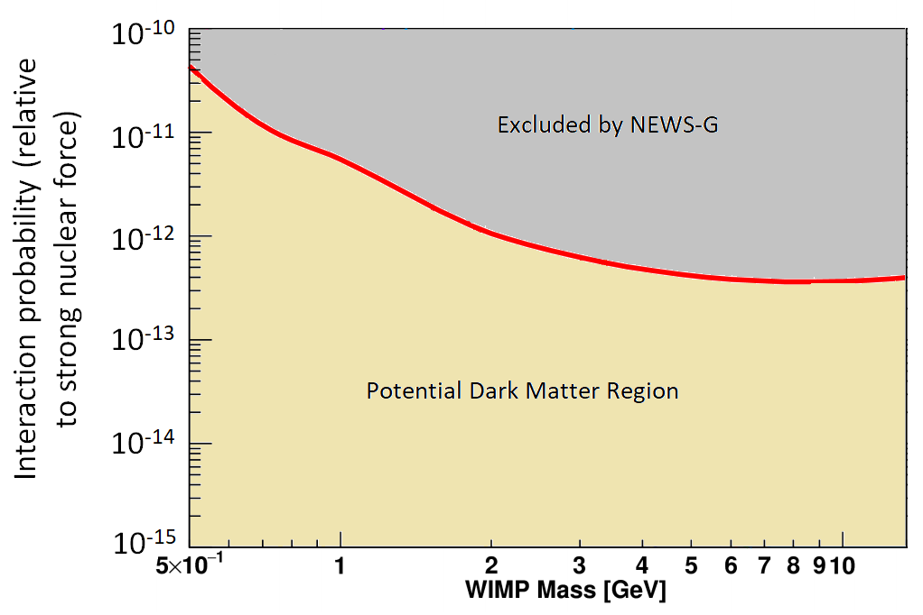

Figure : Adapted from Nikolopoulos (2020)

1. If a WIMP had a mass of 3.25 x 10-27 kg, what would the maximum probability of interaction be it went undetected by NEWS-G?



A WIMP with a mass of 1.83 GeV/c2 would have an interaction probability (cross section) of approximately 2.0 x 10-12 (one trillionth) that of the strong nuclear force between nucleons.

The plot below shows the results of several different dark matter experiemnts; the results of NEWS-G are represented by the red curve. Each of the curves indicate the regions where each detector sets limits on the masses and interaction ability of possible dark matter. The regions above and to the right of each curve shows where the detector would have detected dark matter; the region in below and to the left of each curve indicates where the detector was not able to search.

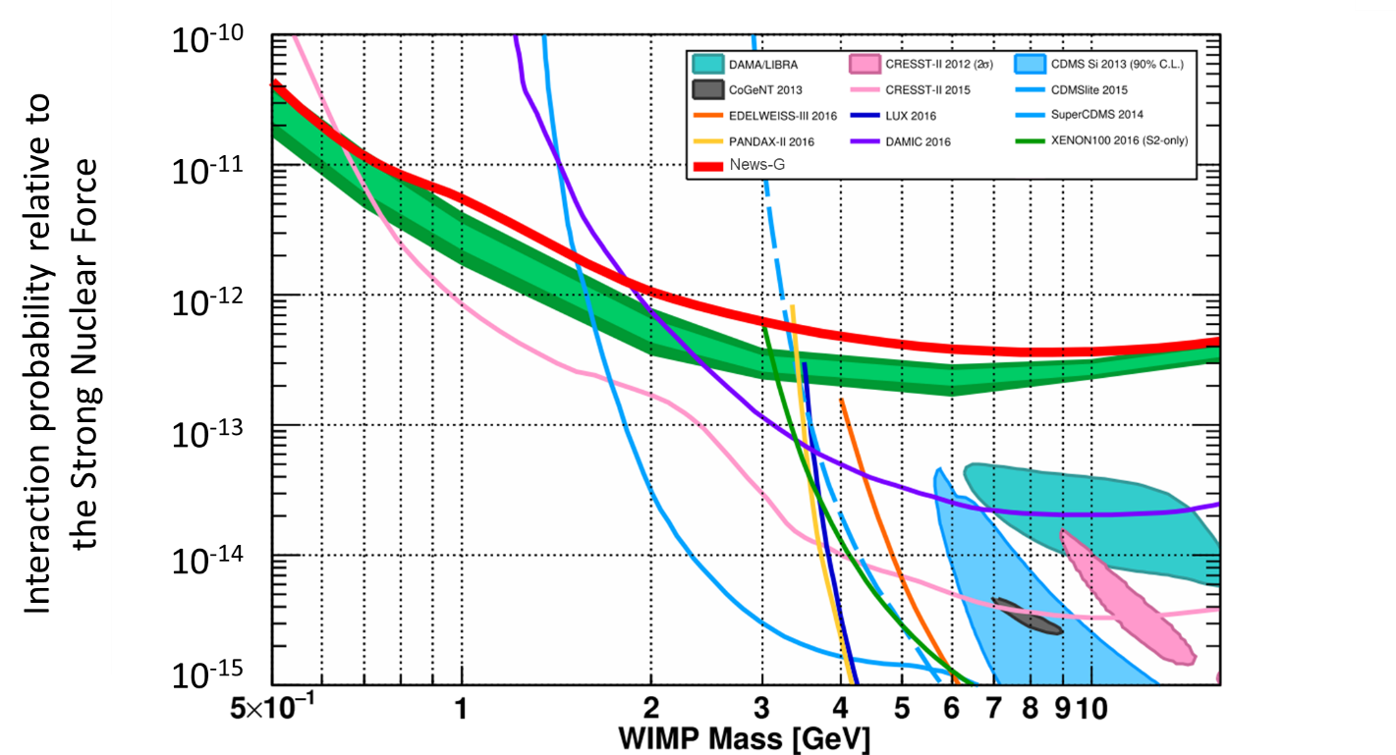

1. Shade the area on the graph where WIMPs are most likely to be found. Compare the properties of WIMPs in this region to electrons and protons.

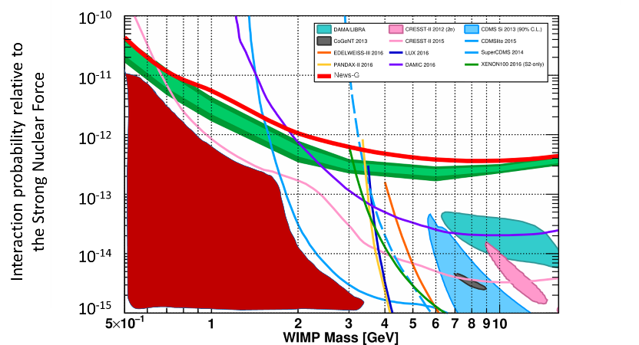

1. Which detectors are most likely to detect a 3.0 GeV WIMP? Which detector is most likely to detector a 1.0 GeV WIMP?

At 3.0 GeV SuperCDMS

At 1.0 GeV CRESST-II 2015

1. Each dark matter experiment uses a different approach to searching for dark matter. Why is in important to use many different detectors that use rely on different physics?

Each experiment uses different physics which allows them to be sensitive to different regions of mass/interaction probability. In addition, having multiple detectors that rely on different underlieing physics means results can be corroborated and cross referenced. If one detector has a positive result but a second detector with similar sensitivity does not the results need to be carefully scrutinized. Conversely if both detectors get positive signals at similar masses they are more likely to represent a positive detection.

1. Katsioulas, Ioannis. (2020). Recent advancements of the NEWS-G experiment. Journal of Physics: Conference Series. 1468. 012058. 10.1088/1742-6596/1468/1/012058.
2. https://en.wikipedia.org/wiki/Townsend_discharge