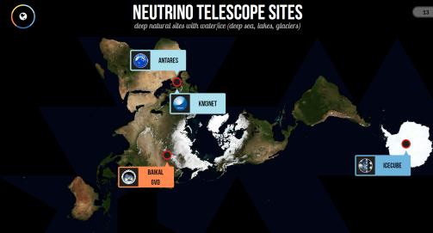
IceCube and the Standard Model
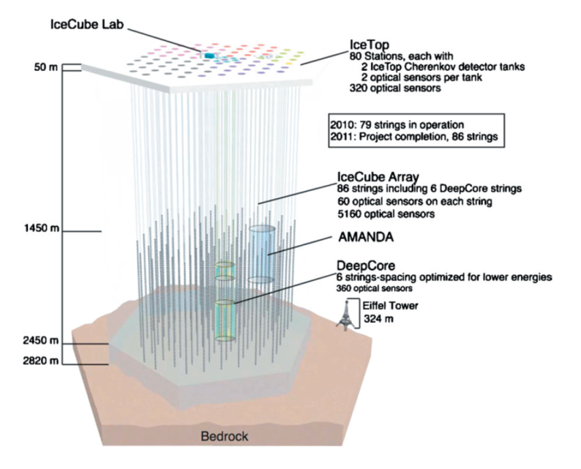
Neutrinos are the second most numerous particle in the universe (after photons). Despite this, they are very difficult to detect. They do not easily interact with matter- as an uncharged lepton they don’t experience the Strong Nuclear Force or the Electromagnetic Force. This leaves only gravity (which is nominally too weak to have any effects on small scales) or the Weak Force. A typical electron neutrino can travel through up to a light year of lead before interacting with it! As a result, detecting Neutrinos can be incredibly challenging. The largest Neutrino detector in the world is in Antarctica and is made up of a cubic kilometer of ice (Its creatively named the IceCube Neutrino Observatory).
The detector is made up of 86 strings of Photomultiplier tubes that detect the radiation from the decay of a passing Neutrino. Occastioanlly, a Neutrino passing through IceCube will interact with a nearby particle and as a result, decay into an Muon (a subatomic particle similar to an electron). This particle travels through the ice that makes up the detector at close to the speed of light producing a form of radiation known as Cherenkovv Radiation. Photomultiplier tubes (PMT) are then used to detect this radiation.
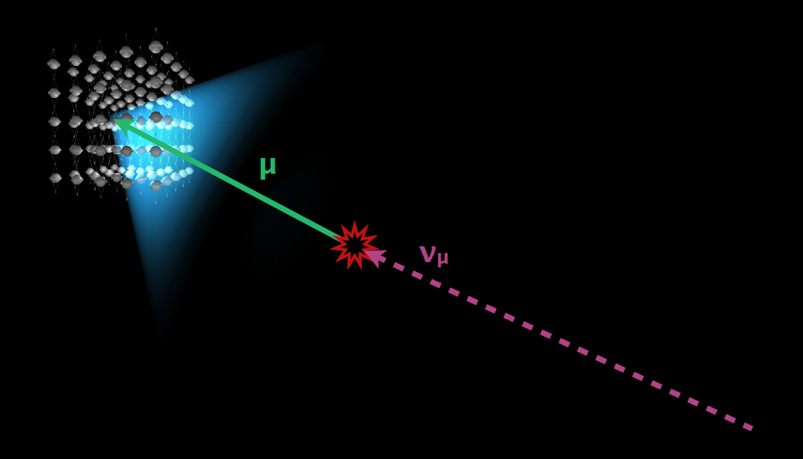

Photomultiplier tubes work by using the photoelectric effect along with a number of dynodes. Each dynode is set at a potential difference of 100 V greater than the previous one. As photon strikes a photoelectric material inside the tube it releases and electron. The electron is accelerated by the potential difference in the dynode. When it strikes the Dynode it releases 5 electrons which are directed towards the next dynode. Each dynode produces 5 electrons for every incident electron. The photomultiplier tubes in IceCube have 12 dynodes in them.
Figure 1: Ice Cube Photomultiplier tubes
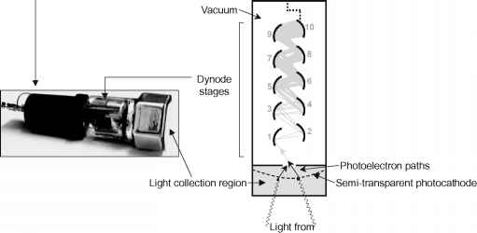
Questions
- What is Cherenkovv Radiation?
- A muon (symbol μ) has a charge of -1, a mass of 105.7 MeV/c² and a half life of 2.20 x 10⁻⁶ s.
  - In Muon decay, three particles are produced. One of them is an electron and one is an antineutrino. Determine the charge on the third particle.
  - Determine the mass of a muon in kilograms.
  - An initial sample of 2000 muons is monitored. Some time later 120 electrons are observed as the result of muon decay. How much time has passed?
- The photoelectric surface in photomultiplier tube has a work function of 2.3 eV. If the radiation caused by a massing neutrino has a wavelength of 415 nm determine the kinetic energy of the first electron in the PMT.
- How much energy does an electron gain passing from one dynode to the next?
- What will the speed of the photoelectron in question 3 be when it reaches the first dynode?
- For every electron that strikes a dynode, 5 electrons are produced. If one electron is produced by the photoelectric surface at the front of the PMT how many electrons would be detected after all the dynodes have been used?
- The most energetic neutrino that has been detected by the IceCube Observatory had an energy of 2.0 PeV. Determine this energy in Joules. How fast would a 10 g bullet have to travel to have the same amount of energy?

