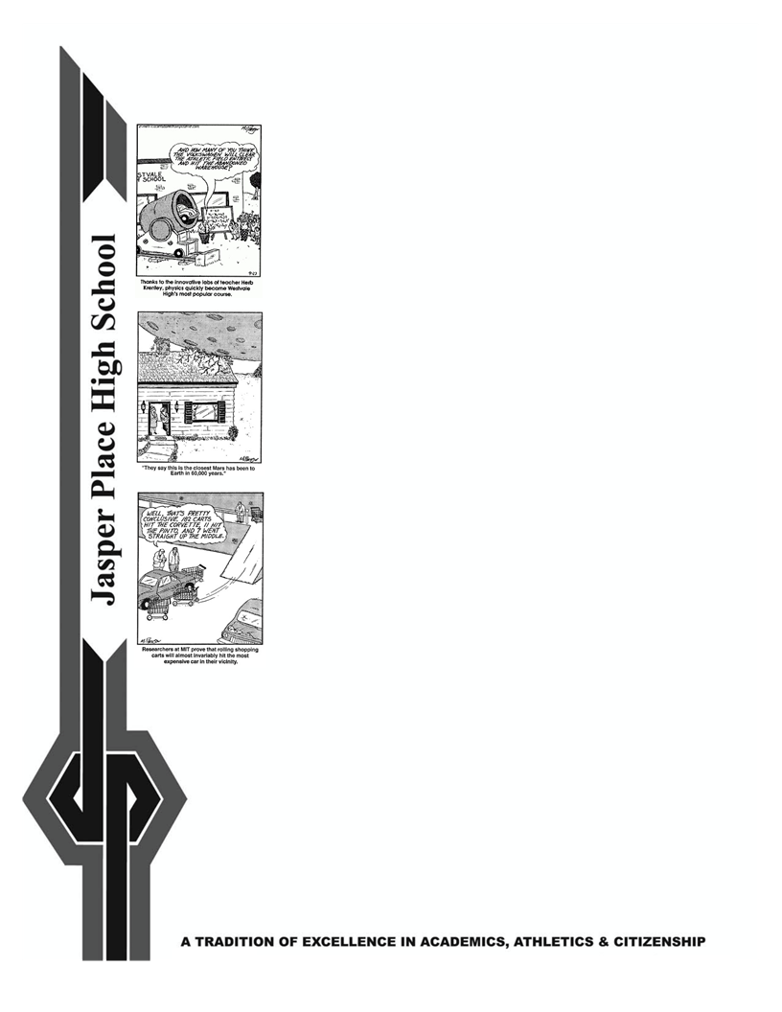
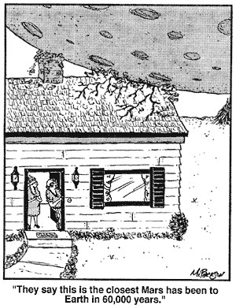
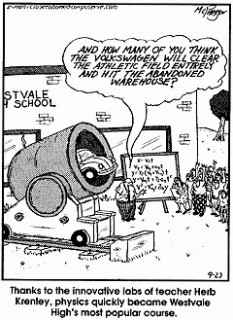
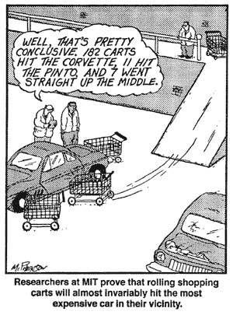
Physics 20

Teacher: Mr. Doktor
Teacher email: ian.doktor@epsb.ca

Alberta Program of Studies Component:
This is a 5-credit academic science course in which students will investigate changes in the position and velocity of objects and systems in a study of kinematics, investigate causes of change in the position and velocity of objects and systems in a study of dynamics and gravitation, extend their study of kinematics and dynamics to uniform circular motion and to mechanical energy, work and power and investigate simple harmonic motion and mechanical waves.

COURSE OUTCOMES:
In Physics 20 students will:
- Describe motion in terms of displacement, velocity, acceleration and time
- Explain the effects of balanced and unbalanced forces on velocity
- Explain that gravitational effects extend throughout the universe
- Explain circular motion using Newton’s Laws of Motion
- Explain that work is a transfer of energy and that conservation of energy in an isolated system is a fundamental physical concept
- Describe the conditions that produce oscillatory motion
- Describe the properties of mechanical waves and explain how mechanical waves transmit energy

More detailed information can be found on the Alberta Education Web
Site at: http://www.education.gov.ab.ca/

ASSESSMENT:
Term and final marks are cumulative. The final mark will be calculated on the basis of the following:

Unit 1: Kinematics Exam 18%
Unit 2: Dynamics Exam 18%
Unit 3: Circular Motion, Work and Energy Exam 18%
Unit 4: Oscillatory Motion and Mechanical Waves Exam 18%
Final Exam 28%

Quizzes, Labs and other Assignments will be worth 20% of each Unit.
Unit Exams will be worth 80% of each unit.

