Atomic Spectra Lab
Problem: Identify the unknown gas using its atomic Spectrum.
Materials:
- Littrow Spectroscope with a diffraction grating of 300 lines/mm
- Emission Tube

Procedure:
- Turn on the Emission Tube and find the Central Maximum in the Eyepiece of the Diffraction Grating. Adjust the position of the central maximum so it is just visible on the far Right Side of the Eye Piece.
Approximate Position of Central Maximum
- Record the Angle Measurement of the Central Maximum.
- Slowly Turn the Diffraction Grating until the Spectral Lines appear in the eye piece. Position one of the lines so it appears in the same location the central maximum was. Record the colour and angle measurement.
- Repeat Step 3 for at least 3 more lines. Do not turn the grating too far. If you start to see the lines repeated you have gone past the first maximum to the central maximum.
Observations:
Angle Measurement for Central Maximum: _____________
Spectral Line Colour | Angle Measurement
Analysis:

- Determine the separation of the slits on the diffraction grating.
- Determine the wavelength for each of the spectral lines you measured.

Conclusion:
- Compare your results to the spectra below. Use your results to identify the gas in the emission tube.
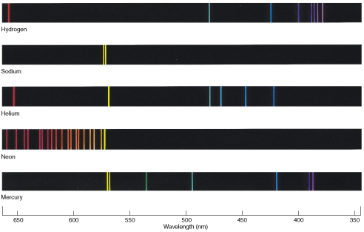

Extension
Like Mechanical Waves, Light can also experience a Doppler shift. When light is Doppler Shifted its frequency and wavelength change. If a star is moving towards the Earth the light from the star has its frequency increased and the spectral lines will all be blue shifted. If the star is moving away from the Earth the frequency will decrease and the spectral lines will be blue shifted.
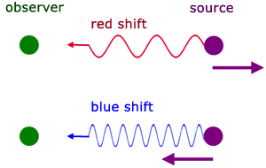
By comparing where a spectral line should be and where it actually is we are able to determine how fast a star or galaxy is moving towards or away from us.
