MAPPING ELECTRIC FIELDS

OBJECTIVE:
To determine the electric field and lines of equipotential around a set of parallel plates.

PROCEDURE:
- Connect the wires from the power supply to the conductors on your apparatus.
- Turn on the voltmeter and set it to read a maximum of 20.0 V DC
- Be careful to not tear the carbon paper
- Place the positive lead (red) of the voltmeter at the 6,6 coordinate (the center of the graph paper). By doing this, you are arbitrarily designating the center of the graph paper as zero electrical potential. Place the negative lead (black) on each coordinate point drawn on the carbon paper. For each reading keep the red lead in place (on the 6,6 coordinate). This will give you a reading of the electrical potential difference between each coordinate and the reference point (the 6,6 coordinate). Record each reading in Excel using the data table template below.

DATA TABLE: Electrical Potential
Create am excel spreadsheet like the one below and enter your data directly into Excel.

 | x- direction
y- direction |  | 1 | 2 | 3 | 4 | 5 | 6 | 7 | 8 | 9 | 10 | 11 | 12
 | 1
 | 2
 | 3
 | 4
 | 5
 | 6
 | 7
 | 8
 | 9
 | 10
 | 11
 | 12

PRODUCING A 3-D MAP
- Open your excel data table.
 |  | X-direction
 |  | 0 | 1 | 2 | 3 | 4 | 5 | 6 | 7 | 8 | 9 | 10
Y-Directions | 0
 | 1
 | 2
 | 3
 | 4
 | 5
 | 6
 | 7
 | 8
 | 9
 | 10

- Highlight all your data cells (do not include the coordinates (0 -10) for either axis.
- Click on Insert and Chart
- Find the Surface chart and use the first chart.
- Print the chart.
DRAWING EQUIPOTENTIAL LINES AND THEN FIELD LINES
On a topographical map, contours are lines drawn on the surface that have equal elevation.

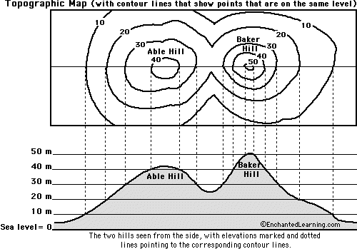

Equipotential lines are similar in that they have equal electrical potential. Along any equipotential line the potential difference is zero.
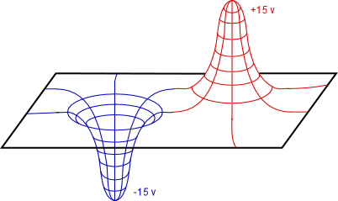
Looking from a top view, steeper regions have contour lines that are closer together, while flatter areas have contour lines that are further apart.

- Draw the electrical field lines. Remember that electric field lines show the direction a positive charge will go and that positive charges ‘roll’ down electric potentials.
- Show the strength of the field by their density.
- Draw the equipotential lines. These lines are scalars and are always perpendicular to the Electric Field.

- Choose one column of X-direction numbers you feel best represents your 3D data. Using Excel create an X-Y scatter plot of this graph. Be sure to label the x and y axis. What do the y-intercept and slope represent?

CONCLUSION QUESTIONS:
1) Explain how the electric field on a 2D surface can be compared to a topographical land surface.

2) Describe the shape of the topographical surface for point charges compared to parallel plates.

3) What electrostatics physics quantity does the height (elevation) of the topographical surface represent?

4) What electrostaics physics quantity does the slope of the topographical surface represent? __________________________

5) A ______________ charge will move downhill on the topographical surface, while a _______________ charge will move uphill on the topographical surface.

