Lesson 2: Calibrating PICASSO
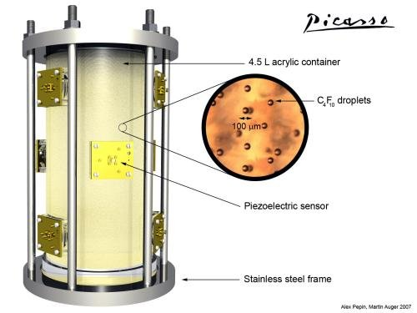
Background
PICASSO is a bubble chamber that has been used in the search for dark matter. It is designed to detect the interaction of dark matter particles with droplets of Perflubutane (C₄F₁₀). These droplets are held in a metastable, superheated state and undergo nucleation (they turn to a gas) when a dark matter (or other subatomic) particle interacts with them. The phase change produces a bubble that can be seen and recorded by piezoelectric sensors that measure the sound produced by the phase change.
PICASSO is sensitive enough to routinely pick up background radiation from numerous sources such as cosmic rays and naturally occurring radioisotopes. If this background radiation is analyzed, it is possible to separate it from a potential dark matter signal. In this activity, data from PICASSO will be used to identify signals produced by particles and signals produced by other effects.
The plot below from a data run made by PICASSO (available in the EXCEL file PICASSO Dataset) and shows the voltage recorded by a piezoelectric sensor during the time it was operating. If a radioactive alpha emitter is placed near the detector, the resultant signal can be used to help identify the characteristics of background alpha radiation. A source of alpha particles was placed near the detector and the signal from one of the piezoelectric sensors was recorded.
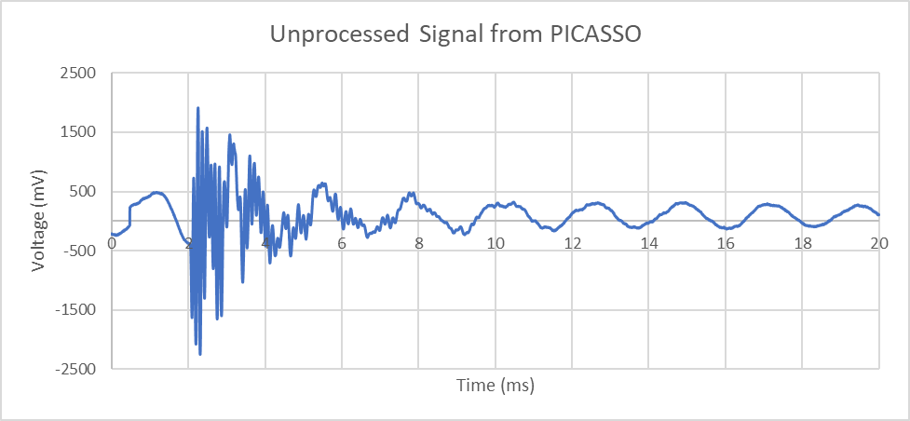
The graph in this plot is made up of two different signals. One signal is from the nucleation of a bubble in PICASSO (the sound from the bubble popping), the other signal comes from background sources such as radiation from space, the electronics in the detector or even a residual signal from a previous bubble event. When the alpha source is removed, the sensor again records the readings from the Piezoelectric sensor. A second plot is produced from these readings.
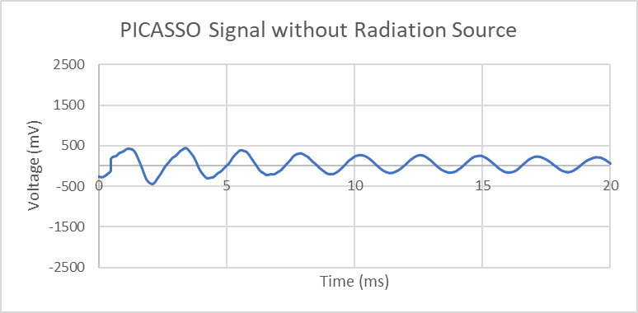
Part I
- Look closely at the graph of the background signal. Describe the features of the graph. What type of function could model this data? Suggest some physical reasons for the signal. Extension: Mathematically model this graph using a sinusoidal function in the from
Oscillating, periodic, sinusoidal graph. Amplitude is decreasing over time. Possible explanations: External vibration of sensor. Electronic noise. Residual signal from previous event.
$$y=500\sin\left(πx\right)$$
- Determine the approximate amplitude and period of the graph. Explain how knowing that information may be helpful in determining the cause of the background signal.
Period is approximately 2.0 ms. Amplitude starts at around 500 mV (at t = 0s) and ends around 200 mV (at t = 20 s).

It is possible to see what external influences may have the same period. The decreasing amplitude may also mean that the signal will eventually disappear and could be the result of a previous event.

- Examine the Unprocessed Signal graph. At what time does the nucleation event first begin? Approximately how long does it last?
From approximately t = 2.0 s to t = 5.0 s
The graph below shows the unprocessed signal with the background signal plot superimposed on it from 2.0 s to 5.0 s. Use this graph to answer the next two questions.

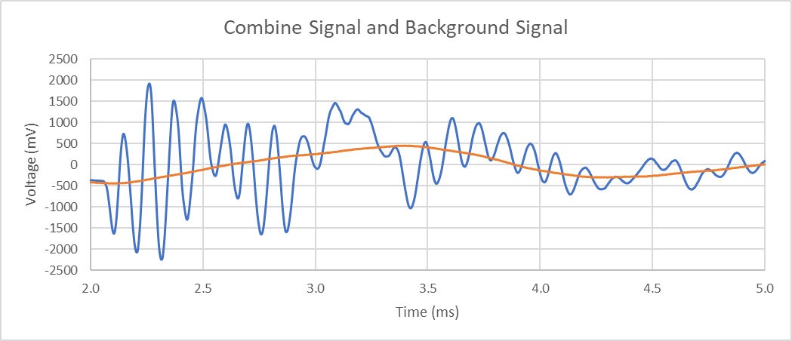

- Recall that the combine signal (blue plot) is the result of the signal from the alpha source and the background signal (signal). To isolate the alpha source signal, you need to subtract the background signal from the combine signal. Determine the magnitude of the alpha source signal by subtracting the background signal amplitude from the combine signal amplitude at the times indicated below:
  - t = 2.0 ms approximately 0 mV (actual = 45 mV)
  - t = 2.5 ms approximately 1600 mV (actual = 1617 mV)
  - t = 3.5 ms approximately 0 mV (actual 15 mV)
  - t = 4.5 ms approximately 500 mV (actual 395 mV)
- Based on your answers from question 4 and using the grid below, sketch a rough graph for the alpha source signal (after the background signal has been subtracted). See final graph in question 7
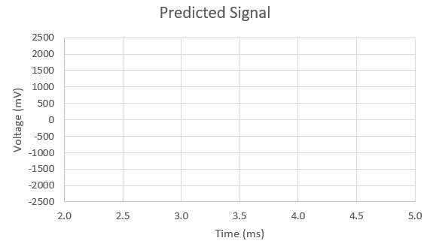

- The combine signal plot is the result of signals interfering with each other. To extract just the alpha source signal the subtraction done in question 4 needs to be done for every data point. The data that produced these graphs contains over 8000 data points so doing it by hand is not practical. However, spreadsheet software like Excel or Google Sheets can aid in this work. Open the .xls file titled PICASSO data set. You will see data arranged in the following headings:
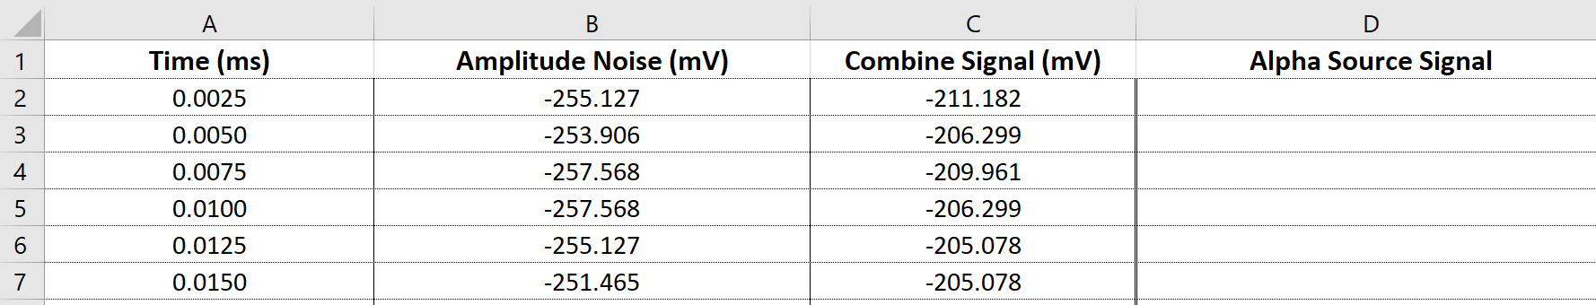
Both Excel and Google Sheets allows calculations to be done with the data inside the cells. Click on cell D2 (the first cell under the Alpha Source Signal). To instruct Excel or Google Sheets to perform a calculation type the following into cell D2.
=C2-B2
Alternatively, after you enter the equal sign, you can simply click on the cells instead of typing them in. This equation will subtract the value of cell B2 from the value in C2. If you have done everything correctly, D2 should now have a value of 43.945.
Note: You can also add or edit a formula by clicking on the formula bar above the cells
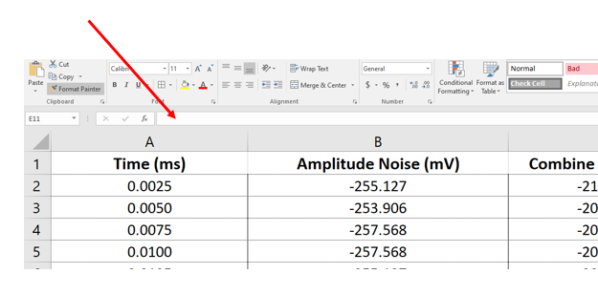
The real usefulness of excel and google sheets is not just their ability to do calculations like this. Click on cell D2 then press:
↓
Shift
Ctrl

This will highlight all the cells in the that column except the column labels. (You may have to use the slider bar on the right to go back to the top of the sheet). Then select the Fill and Down options.

This will perform the subtraction for all the cells in the dataset.
- Create a graph of this data by pressing [crtl] and clicking on column A and D. Next click on Insert and Chart. Choose either a scatter or smooth line chart and add it. Use the Chart Design and Chart Elements option to add a title, x-axis, y-axis labels and units.
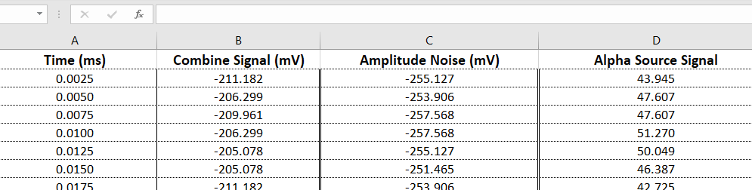

- Compare the new graph with the initial Combine Signal graph. Identify any significant changes. What time intervals correspond to the nucleation event? How long does it last?
The entire graph is translated upwards. The initial amplitude is much closer to zero. The time the maximum amplitude occurs changes.
Part II
- The graph below represents the processed data (background signal has been removed) in the file PICASSO_Dataset2.xls showing a second signal detected by the piezoelectric sensors. The scientist who processed this signal has misplaced the original, unprocessed signal and is interested in reconstruct the original signal.

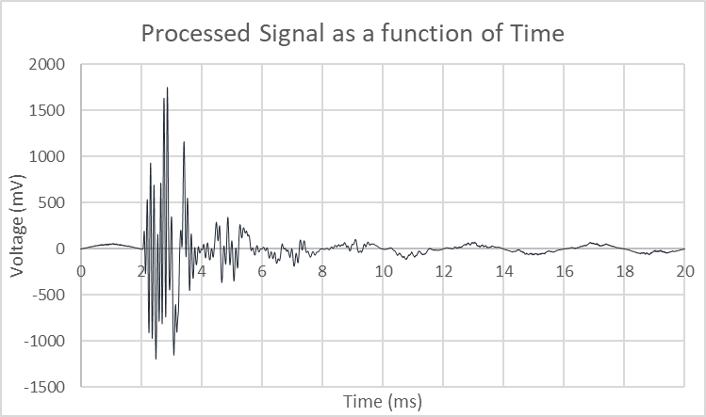

She has managed to identify the original background signal, shown in the graph below.

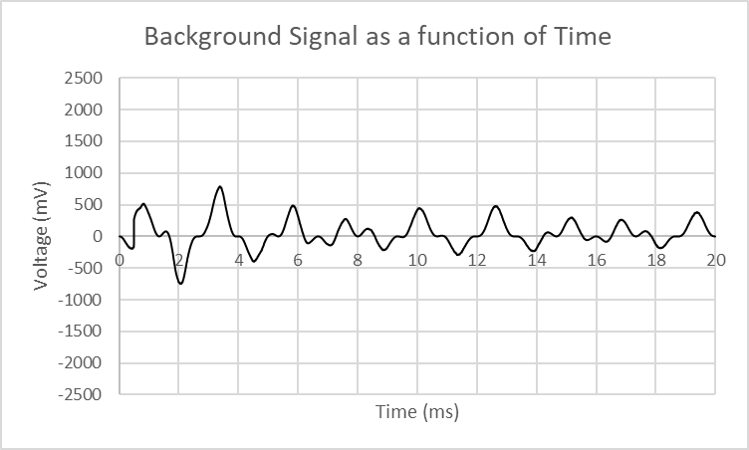

The scientist has selected the times indicated below to determine calculate the combine amplitude at. Complete the table below to determine the result of the constructive interference of the two waves. The first row is done for you.
Time (ms) | Background Signal (mV) | Processed Signal (mV) | Original Signal (mV)
0.50 | -150 | +15.0 | -135
1.0 | +500 | +35 | +535
2.0 | -700 | 0 | -700
2.5 | 0 | +800 | +800
3.0 | +400 | +1700 | +2100
5.0 | 0 | +300 | +300
10 | +475 | 0 | +475

- Based on the results of the table above and using the two graphs above, make a prediction of what the original graph looked like. Sketch your prediction in the space below.

- Open the file PICASSO_Dataset2.xls using either Excel or Googlesheets. Using the steps from the previous dataset, add the background signal and processed signal columns (in cell E2 enter =B2+C2. Highlight all the cells and use the fill down command to calculate the values of the original signal. Using the data in row E and row A, create a graph that represents the Original Signal as a function of time. Compare the graph to your prediction in question 2.

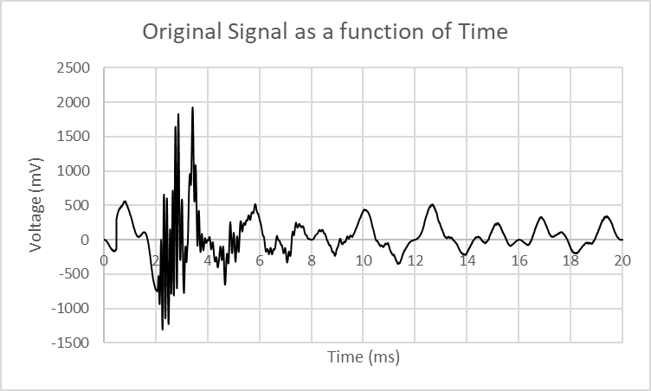

Conclusion
- The detection of alpha particles in PICASSO has a characteristic amplitude. When an alpha particle interacts with the detector is will produce plots with a maximum amplitude similar to the those on the graph you have just created. Identify this maximum amplitude. Compare it to the maximum amplitude of the original graph.
Amplitude is approximately 2000 mV. Original was approximately 1700 mV.

- [Question here about other amplitude signals such as neutrons] Neutrons have a much smaller amplitude; neutrons can deposit energy within nanometer while alphas are micrometers. Compare amplitudes of alpha and neutrons.
- Explain how to determine the resulting amplitude from the interference of two waves.
The resulting amplitude is the algebraic sum of the two original waves. If they both have positive amplitudes the result is a larger wave (constructive interference); if they have amplitudes with opposite signs the result is a smaller wave (destructive interference).

- What is the scientific value in removing a background signal from any detector?
Removing background signals provides a more accurate measurement. Without removing the background signal, it may be confused for the signal being investigated.

