NEWS-G – Teacher Information
New Experiment with Spheres – Gases
NEWS-G Background and Operations
One approach to the direct detection of dark matter is using an inert gas inside an ionization detector. In one experiment, called the New Experiment with Spheres – Gases (NEWS-G), a 60 cm metal sphere is filled with 99.3% neon and 0.70% methane. A metal rod is attached to the inside of the sphere and a high voltage is supplied to the it (which functions as an anode), while the sphere itself is rounded (and thus acts as a cathode). Figure 1 shows the 60 cm diameter metal sphere on the left and the central metal rod in the interior of the sphere.
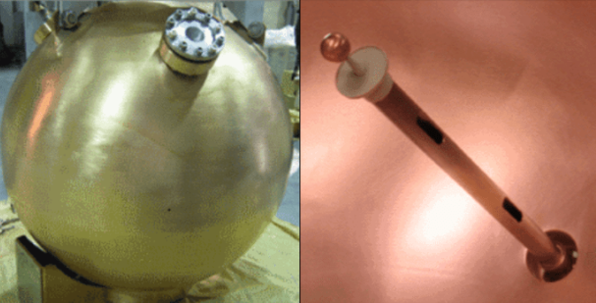
Figure 1: NEWS-G sphere and inside image of central spike
A cross section diagram of the NEWS-G experiment is shown in figure 2.
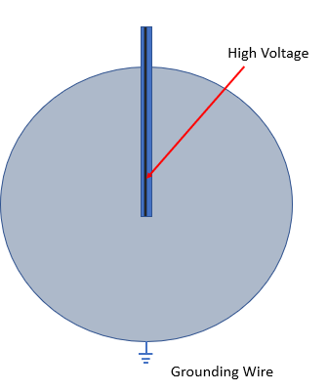
Figure 2: NEWS-G cross section
When an ionizing particle enters the detector, it causes ionization and produces an electron and a positively charged ion. As a result of the high voltage applied to the central spike, the electron drifts towards the center of the sphere. The electric field inside the sphere must be high enough to prevent the electron and positive ion from quickly recombining but at the same time it must be low enough to prevent the produced electron from producing further ionization events in nearby atoms (this is the process that happens in a Geiger Mueller counter). In this way, the detector is a capable of using the number of electrons detected at the anode to reconstruct the energy of the particle that entered the detector. The current produced at the anode by electrons in the sphere is directly proportional to energy of the incoming particle. Because of this ability, NEWS-G belongs to a class of detectors known as proportional counters.
As illustrated in the graphic below, when a dark matter particle passes through NEWS-G it may ionize one of the atoms in the detector. The electron in this image can be seen accelerating towards the central spike (because of the high voltage applied to the central spike).

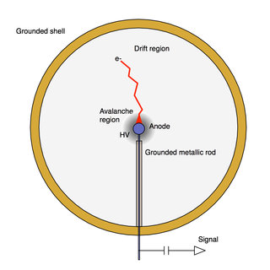
Figure 3:Electron motion in NEWS-G

Calibration
Precise Calibration is critical to the operation of NEWS-G. The detector is capable of picking up background radiation from nearby radioactive sources such as radioactive lead or uranium that naturally occur in rocks or from high energy particles from outer space. To detect the faint background signal from a dark matter particle it is crucial that physicists understand what the signals from these background sources look like. Because each type of particle will carry a different amount of energy NEWS-G has the distinct advantage of being able to identify the energies of particles that pass through it. If properly calibrated, the signal from an electron will look very different from a neutron or an alpha particle.
The detector response was determined for both neutrons and X-rays using radioactive isotopes. Neutron calibration was done using an Americium-Beryllium (Am-Be) source with an established rate of neutron production while X-ray calibration used ³⁷Ar which produces 2.82 keV and 270 eV X-rays through electron capture of the K (1s) and L (2s and 2p) shells. Using these two energy events, scientists can determine whether the detector response is linear – what ranges of energy deposition produce a predictable response from the detector.
Am-Be sources contain a mixture of Americium and Beryllium. The alpha particles produced by the decay of Americium react with Beryllium to produce a neutron and Carbon-6:

Once a radioactive source is placed near or inside the detector, the number of event counts are recorded. When an ionizing particle enters the detector, it ionizes a gas atom and produces an electron. The electric field inside the detector causes the electron drifts to the central anode and is recorded as current. Each event produces a specific current spike in the detector and the amplitude of this current is proportional to the energy of the incoming particle. The histogram in figure 4 shows the results of a calibration run using Ar-37. The two peaks correspond to the two electron capture events that occur in Ar-37. The blue data points are the raw data from the detector and the red line represents the curve fit from the theoretical model used in this experiment.
``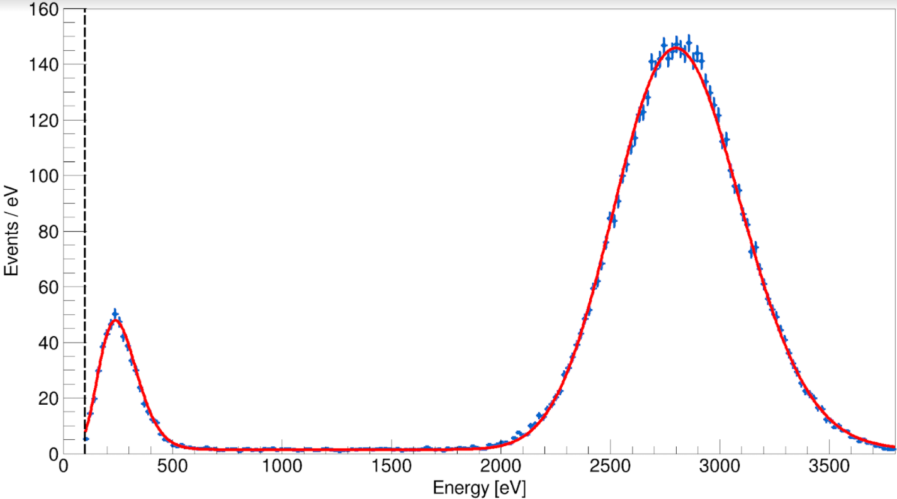

Figure 4: Histogram of events from NEWS-G Calibration
Modeling Detector Response
Computer simulations of the detector response is important to test how well the detector is working and in demonstrating an understanding of the physics behind its operation. The models used include parameters such as the minimum energy used to create ionization events, the efficiency at converting received signals into energy and the number of electrons produced by secondary ionization near the anode. A model that is well calibrated with observations allows physicists to then predict properties of dark matter such as the mass and cross section which then allow predictions to be made regarding the rate of dark matter detection. Finally, it allows for the discrimination of different types of particles. Computer simulations provide physicists with the ability to identify a particular event as an X-ray or electron which then allows background radiation to be identified so it won’t be confused with dark matter signals.

Results
In 2017 NEWS-G operated for 43 days at the Laboratiore Souterrian de Modane (LSM). LSM is an underground laboratory located in the Frejus tunnel between France and Italy under nearly 3000 m of rock. During this time, the detector did not conclusively detect any dark matter particles but was able to establish limits on the mass and relative interaction (called the cross section) of any dark matter particles. Based on the results from this experiment, a 6 GeV dark matter particle cannot have a likelihood of interaction of more than roughly 1 trillionth (10⁻¹²) the interaction of the strong nuclear force between protons and neutrons or they would have been detected by NEWS-G. The plot below (figure 5) shows the results from NEWS-G across several different masses. If dark matter particles had masses above the red line (NEWS-G’s results) they would have been detected. As a result, new experiments and theories will concentrate on searching below that line.

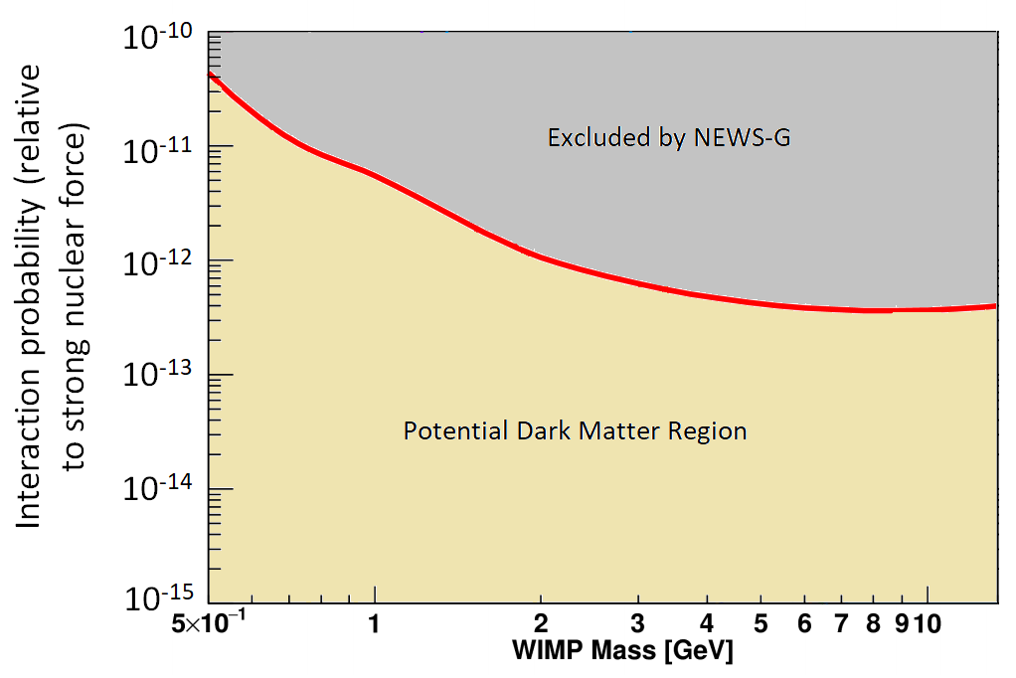
Figure 5: Dark Matter Interaction adapted from Nikolopoulos (2020)

For more information on NEWS-G and the experimental data it gathered visit the website below or scan the QR code.
https://news-g.org/news-snolab/
Figure 3:https://news-g.org/news-snolab/

Katsioulas, Ioannis. (2020). Recent advancements of the NEWS-G experiment. Journal of Physics: Conference Series. 1468. 012058. 10.1088/1742-6596/1468/1/012058.

