**Activity 2: Orbital Motion in the Solar System**

**Background**

In the 1600s Kepler and Newton began what would become a rigorous campaign to quantify the motion of celestial objects. Kepler’s 3rd law of planetary motion related the period of an object’s orbital motion to the semi-major axis of its orbit, shown in equation (1)

Instead of expressing this equation in terms of period, using the equation for centripetal speed,  
 (2) 

Allows Kepler’s law to be expressed in terms of semi-major axis and average orbital speed.

(3) 

(4) 

(5) 

Because everything in the numerator of equation 5 are constants, this shows that the semi-major axis of an object in a stable orbit is proportional to the inverse square of the velocity.

(6)

Building on this relationship, Newton applied his Law of Universal gravity to orbital motion as shown in equation (7).

(7) 

(8) 

(9) 

Careful observations of the planets in our solar system allowed astronomers to determine the periods of their orbit around the Sun. Using Kepler’s 3rd law, it was possible to calculate the length of the planet’s semi-major axis. Using this information, determining the orbital speed of each planet was relatively straightforward.

**Problems:**

1. Using the equation for uniform circular motion (2) and assuming the planets travel in circular orbits use the information in the table below to determine the orbital velocity of the planets.

|  |  |  |  |
| --- | --- | --- | --- |
| Planet Name | Period (days) | Orbital Radius (km) | Orbital Speed (m/s) |
| Mercury | 88.0 | 57.9 x 106 | 4.78 x 104 |
| Venus | 224.7 | 108 x 106 | 3.50 x 104 |
| Earth | 365.3 | 150 x 106 | 2.99 x 104 |
| Mars | 687.0 | 228 x 106 | 2.41 x 104 |
| Jupiter | 4332 | 779 x 106 | 1.31 x 104 |
| Saturn | 1.076 x 104 | 143 x 107 | 9.66 x 103 |

1. Create a graph of orbital speed vs orbital radius along with a line of best fit. What assumptions are necessary to extrapolate beyond the line of best fit?

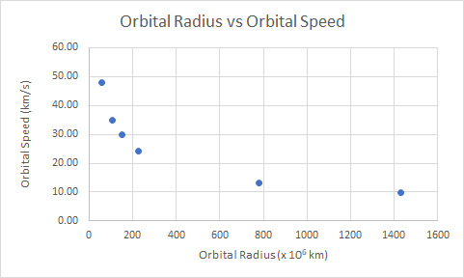

1. Using Newton’s Law of Universal Gravity and the equation for Centripetal Force, determine the proportional relationship between orbital velocity and orbital radius.

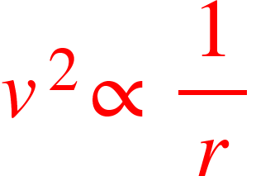

1. Create a graph of the relationship from question 3. What does the slope of the graph represent?

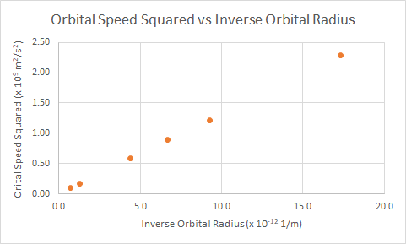

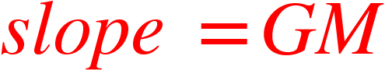



1. The gravitational force keeping the planets in their orbit results almost entirely from the mass of the Sun. Using the results of question 4, determine the mass of the sun.

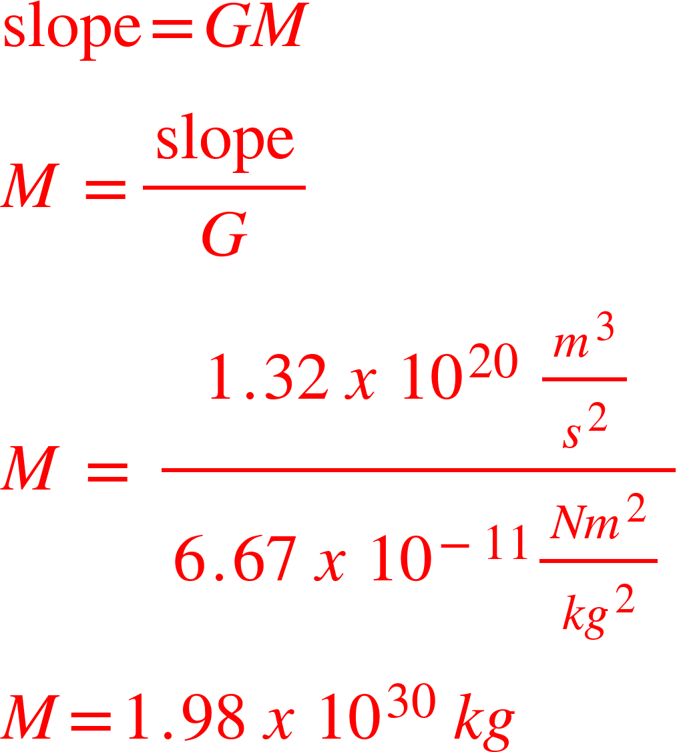

1. The accepted value for the mass of the Sun is 1.99 x 1030 kg. Determine the percent error in your calculation. What are some specific, measurable reasons your answer from question 5 may deviate from the accepted value?

<math xmlns="http://www.w3.org/1998/Math/MathML"><mo mathcolor="#FF0000">%</mo><mo mathcolor="#FF0000">&#xA0;</mo><mi mathcolor="#FF0000">e</mi><mi mathcolor="#FF0000">r</mi><mi mathcolor="#FF0000">r</mi><mi mathcolor="#FF0000">o</mi><mi mathcolor="#FF0000">r</mi><mo mathcolor="#FF0000">&#xA0;</mo><mo mathcolor="#FF0000">=</mo><mo mathcolor="#FF0000">&#xA0;</mo><mfenced mathcolor="#FF0000" open="|" close="|"><mfrac><mrow><mi>o</mi><mi>b</mi><mi>s</mi><mi>e</mi><mi>r</mi><mi>v</mi><mi>e</mi><mi>d</mi><mo>&#xA0;</mo><mo>-</mo><mo>&#xA0;</mo><mi>e</mi><mi>x</mi><mi>p</mi><mi>e</mi><mi>c</mi><mi>t</mi><mi>e</mi><mi>d</mi></mrow><mrow><mi>e</mi><mi>x</mi><mi>p</mi><mi>e</mi><mi>c</mi><mi>t</mi><mi>e</mi><mi>d</mi></mrow></mfrac></mfenced><mo mathcolor="#FF0000">&#xA0;</mo><mi mathcolor="#FF0000">x</mi><mo mathcolor="#FF0000">&#xA0;</mo><mn mathcolor="#FF0000">100</mn><mo mathcolor="#FF0000">%</mo><mspace linebreak="newline"/><mo mathcolor="#FF0000">%</mo><mi mathcolor="#FF0000">e</mi><mi mathcolor="#FF0000">r</mi><mi mathcolor="#FF0000">r</mi><mi mathcolor="#FF0000">o</mi><mi mathcolor="#FF0000">r</mi><mo mathcolor="#FF0000">&#xA0;</mo><mo mathcolor="#FF0000">=</mo><mo mathcolor="#FF0000">&#xA0;</mo><mfenced mathcolor="#FF0000" open="|" close="|"><mfrac><mrow><mn>1</mn><mo>.</mo><mn>98</mn><mo>&#xA0;</mo><mi>x</mi><mo>&#xA0;</mo><msup><mn>10</mn><mn>30</mn></msup><mo>&#xA0;</mo><mi>k</mi><mi>g</mi><mo>&#xA0;</mo><mo>-</mo><mo>&#xA0;</mo><mn>1</mn><mo>.</mo><mn>99</mn><mo>&#xA0;</mo><mi>x</mi><mo>&#xA0;</mo><msup><mn>10</mn><mn>30</mn></msup><mo>&#xA0;</mo><mi>k</mi><mi>g</mi></mrow><mrow><mn>1</mn><mo>.</mo><mn>99</mn><mo>&#xA0;</mo><mi>x</mi><mo>&#xA0;</mo><msup><mn>10</mn><mn>30</mn></msup><mo>&#xA0;</mo><mi>k</mi><mi>g</mi></mrow></mfrac></mfenced><mi mathcolor="#FF0000">x</mi><mn mathcolor="#FF0000">100</mn><mo mathcolor="#FF0000">%</mo><mspace linebreak="newline"/><mo mathcolor="#FF0000">%</mo><mo mathcolor="#FF0000">&#xA0;</mo><mi mathcolor="#FF0000">e</mi><mi mathcolor="#FF0000">r</mi><mi mathcolor="#FF0000">r</mi><mi mathcolor="#FF0000">o</mi><mi mathcolor="#FF0000">r</mi><mo mathcolor="#FF0000">&#xA0;</mo><mo mathcolor="#FF0000">=</mo><mo mathcolor="#FF0000">&#xA0;</mo><mn mathcolor="#FF0000">0</mn><mo mathcolor="#FF0000">.</mo><mn mathcolor="#FF0000">50</mn><mo mathcolor="#FF0000">%</mo></math>

* Assuming all planets’ orbits are perfectly circular.
* Gravitational effects of other planets (primarily Jupiter) are not included in this calculation.
* Other objects (Uranus, Neptune & Dwarf planets) are not considered.