Evidence for Dark Matter
Teacher Resource
Objectives:
- To Introduce students to the evidence for dark matter.
- To allow students to evaluate different forms of evidence.
- To develop an understanding of gravitational, orbital mechanics and the relationship between mass and orbital speed.

Materials:
- Background material
- Activity 1: Research Questions and Introduction with key
- Activity 2: Evidence for Dark Matter with key
- Activity 3: Additional Evidence for Dark Matter with key

Background Information
For centuries, humanity's primary means of investigating the universe has been through optical telescopes. We have looked up at the stars with wonder and amazement while slowly using the light from those distant pinpricks to unravel some of nature's mysteries. And yet, as far back as the late 1880s tantalizing clues were emerging that there might be more to the universe than what we could see with our eyes. In 1884 Lord Kelvin noted that our galaxy might contain objects too dark to see. His hypothesis was based on new observations that showed stars in the central region of the Milky Way moved with speeds not completely consistent with Newtonian dynamics. These objects were initially thought to be objects whose composition were similar to planets or black holes - built from matter consisting of protons and neutrons (baryonic matter).
By the 1930s enough evidence had been collected to make it difficult to ignore the idea of significant amounts of unseen matter. In 1933, Swiss astrophysicist Fritz Zwicky was studying the Coma Cluster, a collection of over 1000 galaxies.
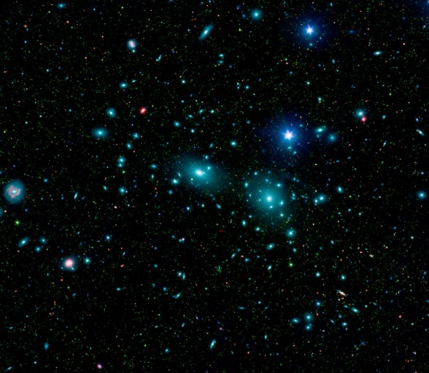
Figure 1: Coma Cluster mosaic from the Sloan Digital Sky Survey
Zwicky noticed that many of the member galaxies were moving too fast for the cluster to remain stable if the only source of gravity was the visible matter they contained. Similar results were soon found by Erik Holmberg and Sinclair Smith as they examined different clusters of galaxies. By the 1960s and 1970s, observations of the rotation rates of stars, globular clusters and clouds of gas in nearby galaxies were made by Vera Rubin, Kent Ford and Ken Freeman. These rotation curves showed a picture of spiral galaxies spinning much faster than possible if the only source of gravity was the visible matter found in the stars and hot gas of the galaxy.
The computer animation below shows the rotation predicted rotation of a hypothetical galaxy that contains only visible matter (right side). This is compared to a second simulated galaxy that closely matches the observed rotation rate of many spiral galaxies (left side). Stars at the outer edge of the galaxy are observed to orbit the center of the galaxy much faster than they should if the only source of gravitational force were the luminous matter in the galaxy.

