Unit 2: Dark Matter Detector – Teacher Background Information
The Search for Dark Matter
Once astronomers realized that many galaxies contain far more mass than suggested by the luminous matter the search began to identify what that ‘dark matter’ was. Whatever dark matter is, it does not interact with matter through the electromagnetic force – it does not emit, absorb, or scatter electromagnetic radiation. This means it must not have an electric charge and so will only be influenced by gravity and the weak nuclear force.
One of the earliest hypotheses was that the dark matter could be clumps of matter like rogue planets, blackholes or interstellar dust and gas. Like the matter that makes up visible stars, this type of matter is made of baryons (matter composed on protons and neutrons as opposed to particles like electrons). Our current understanding of baryonic matter indicates each baryon consists of three quarks and in addition to being affected by the force of gravity and the electromagnetic force it also experiences the strong nuclear force.
u
d
d
Neutron
- 1 up quark
- 2 down quarks
u
u
d
Proton
- 2 up quarks
- 1 down quark

However, while some dark matter may be made of baryonic matter (black holes, cold gas) several lines of evidence lead astrophysics to believe dark matter is likely to be a new type of particle.
Two of the primary hypotheses for the new particles are neutrinos and weakly interacting massive particles. In fact, both may contribute to the Dark Matter in the universe.

The neutrino hypothesis
Neutrinos are very low mass subatomic particles that were first theorized to exist by Wolfgang Pauli in the 1930s in an effort to explain how Beta decay could conserve momentum. For example, in the beta decay of Hydrogen 3 the daughter nucleus (Helium 3) has a recoil velocity that is observed to be perpendicular to the beta particle. This violates the law of conservation of momentum – In this example, the initial momentum of Hydrogen 3 in both the x- and y- directions was zero. However, without the addition of a third particle, the two recoil products now have net momentum in both directions. Pauli proposed a third, unseen particle was produced that conserved momentum.

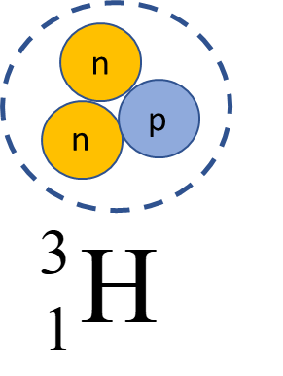
Hydrogen-3 Before Decay

Decay Products
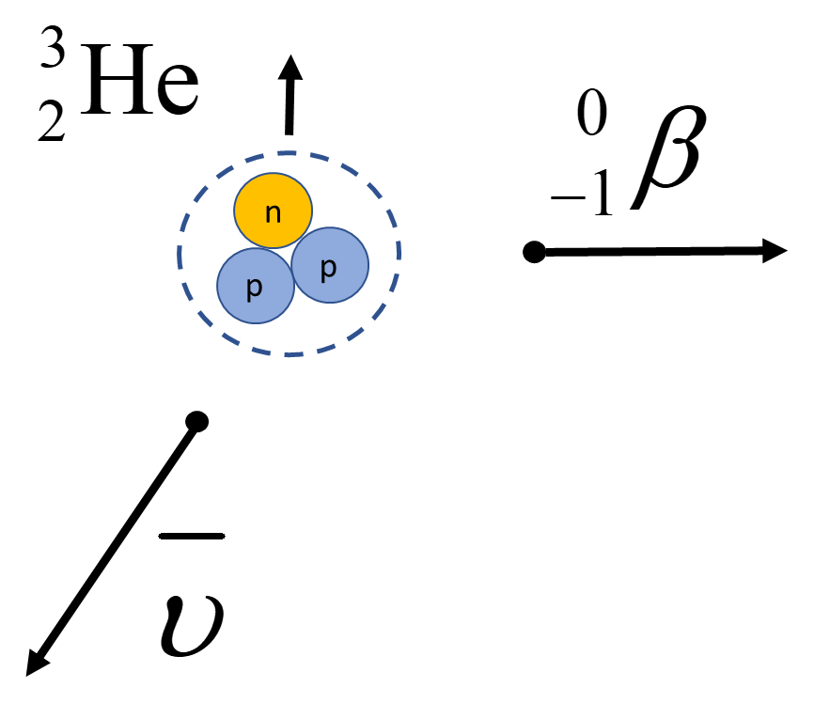
However, while the neutrino carries momentum, measuring its mass and velocity independently remains a challenge into the twenty first century because they interact extremely weakly with regular matter – a light year of lead (9.46 x 10¹⁵ m) would only block about half the neutrinos passing through it.
The idea that neutrinos could be the elusive dark matter that permeates galaxies comes from their very low interaction with regular matter and the nonzero mass they carry. While each individual neutrino is very light (so light in fact we still don’t know what the mass is), they are the second most numerous particles in the universe (after photons). If sufficient neutrinos were present in the halos of galaxies, they could be a potential explanation for dark matter.
However, although neutrinos may constitute a small percentage of dark matter it is unlikely that they make up much of the missing mass. The lowest energy neutrinos observed move at 99.9999999995% of the speed of light (because temperature is directly related to particle speed, neutrinos are often referred to as Warm Dark Matter or WDM). At these speeds, neutrinos are moving too fast to form the dark matter halos observed in galaxies; the speed of neutrinos is greater than the escape velocity of the galaxies dark matter is observed in.
New Particles
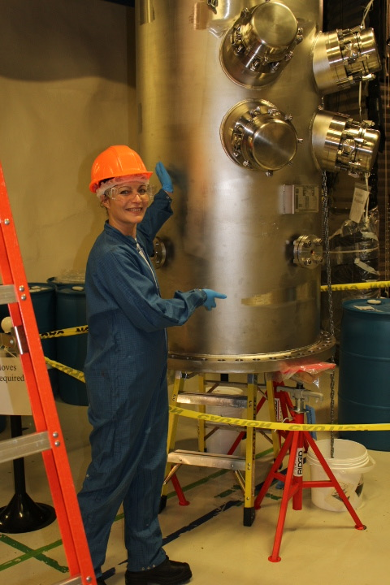
As a result, many physicists like Dr. Marie-Cecile Piro of the University of Alberta are currently searching for a new type of slow moving, massive particle (also known as Cold Dark Matter or CDM).
To be consistent with observed properties the particles Dr. Piro is searching for are uncharged, relatively slow and interact only weakly with normal matter. Known as Weakly Interacting Massive Particles (or WIMPS) detecting these particles remains a major challenge in particle physics.
Several different methods of detection have been attempted. Bubble Chambers have been successfully used to detect and track the motion of charged particles such as protons, alpha particles, and electrons and have been adapted to search for Dark Matter – PICASSO is one such detector.
PICASSO Dark Matter Detector
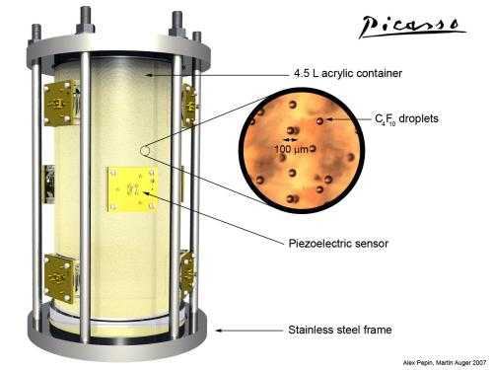
PICASSO is a bubble chamber that contains a superheated liquid of (Perflubutane) C₄F₁₀. Such superheated liquids are in a clean, smooth container that do not contain any nucleation sites (rough surface where boiling can occur) to a temperature above their boiling point. These metastable liquids are very susceptible to boiling. Any slight addition of energy will trigger a rapid transformation from liquid to vapour. It is exactly this property that PICASSO uses to detect incoming particles. Superheated droplets are dispersed in a gel and when a WIMP passes through the detector it can collide with a Fluorine atom in the Perflubutane molecule. The Fluorine atom recoils and transfers some of its kinetic energy to the surrounding liquid. A tiny bubble forms in the superheated C₄F₁₀ which quickly grows until the entire droplet transforms into a vapour bubble. In the video, PICASSO Explained, Dr. Piro briefly explains how the detector operates.
The expanding bubble can be seen and heard using cameras and piezoelectric sensors mounted on the detector. The resources included here contain four animations of different bubble nucleation occurring in PICASSO. These bubble formations can be the result of dark matter, alpha articles, neutrons, or other subatomic particles interacting with the C₄F₁₀ in the detector.
Background Calibration
Although PICASSO is designed to detector Dark Matter particles because it is sensitive to any particles that can interact with the detector medium (Fluorine in this case) it can also pick up Neutrons, Alpha Particles and Neutrinos. To be effective in the search for Dark Matter, it is essential that the detector is as isolated as possible and that the signals from other particles are recognizable and easy to filter out. To isolate the detector, it is operated in SNOLABs clean room, two kilometers beneath the surface of the Earth. Running the detector near known alpha and neutron sources allows those possible background signals to be identified and understood.

