Centripetal Forces
The Gravitron is a ride that simulates artificial gravity by spinning very quickly.
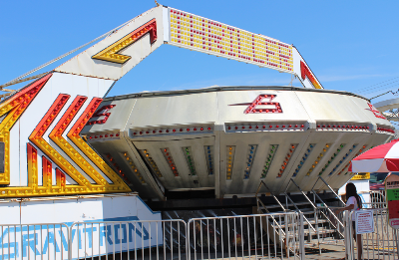

The specifications for the Gravitron are shown below. Use this information to answer the next three questions.

Diameter: 9.0 m
Rotation Rate: 23 RPM
- Draw a diagram shown the direction of the centripetal velocity and centripetal acceleration.

- Determine the centripetal velocity of the ride.

(11 m/s)
- Determine the centripetal acceleration of the ride.

(26 m/s²)
- Compare this acceleration to the acceleration due to gravity. How many Gs would a rider experience?

(2.7 G)
- Determine the centripetal force acting on a 60 kg rider.

(1.6 x 10³ N)
- In order to balance the downwards force of gravity, the rider must experience a force of equal magnitude to gravity. Determine the necessary coefficient of friction between the rider and the ride to provide this force of friction if the Normal Force is equal to the centripetal force.

(0.38)
The Earth
The Earth has a radius of 6.37 x 10⁶ m and a rotational period of 24.0 h. If you were standing on the equator determine the following:
- What would your centripetal velocity be?

(463 m/s)
- What would your centripetal acceleration be?

(3.36 x 10⁻² m/s²)
- Determine the centripetal force acting on a 60 kg person.

(2.02 N)
- What would the centripetal velocity & acceleration be for a person standing on the North Pole?

- BONUS: Using the above answers explain why it is easier to launch a rocket into orbit from lower latitudes (closer to the equator)

