Activity 1: NEWS-G Calibration
Background
NEWS-G (New Experiment with Spheres – Gases) is a dark matter detector that uses a sphere filled with gas to search for ionization events. As a particle of dark matter, know as a weakly interacting massive particle or WIMP, passes through the sphere it may interact with one of the gas atoms inside the sphere. This interaction deposits energy to the atom and can ionize an electron. The sphere is designed with a metal rod in the interior that is has a potential difference of a few thousand volts relative to the sphere itself. This causes the ionized electron to drift towards the anode. As the electron nears the anode it gains energy causing secondary ionization of gas atoms in a Townsend Avalanche, shown in the image below (figure 1):

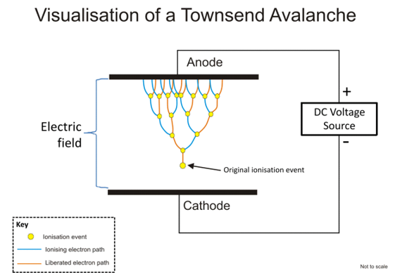
Figure 1:Process of a Townsend Avalanche from Wikipedia
At the anode, the electrons produce a current that is recorded. The current produced in the anode is directly proportional to the initial energy deposited by the WIMP. However, to covert the anode current into the energy of the WIMP, the detector must be calibrated. Calibration can be done using Argon-37 as a calibration source. The graphs below (figure 2) shows the energy of signals received by the detector and the frequency of those signals.
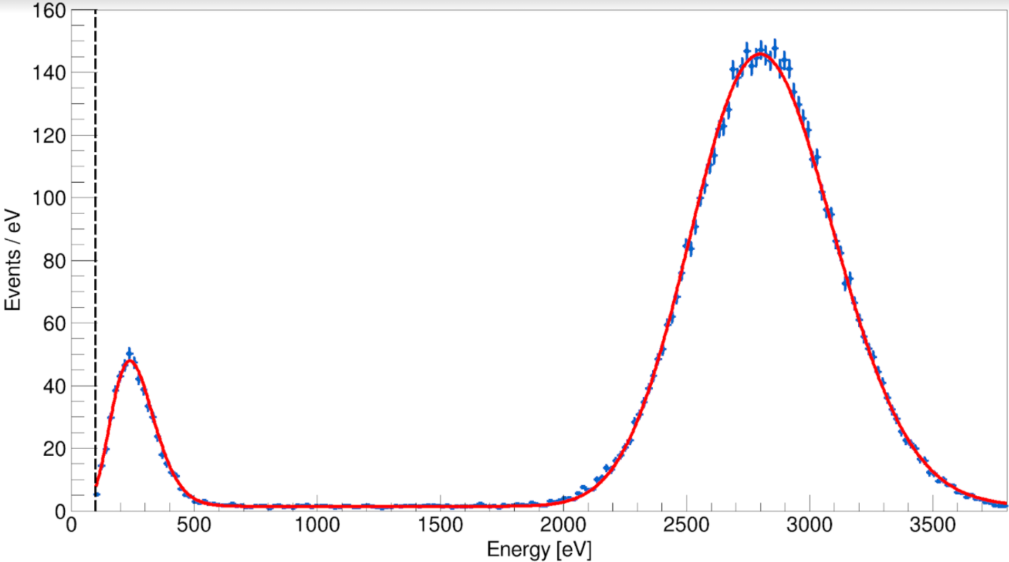
Figure 2: Plot of the number of events compared to the energy of the events

For more information on NEWS-G and the experimental data it gathered visit the website below or scan the QR code.
https://news-g.org/news-snolab/
Figure 3:https://news-g.org/news-snolab/

Activity
- Using the graph, identify the maximum energy of each signal and determine the wavelength of EMR that produced this signal. What region of the electromagnetic spectrum do these photons belong to?
Region 1 – 270 eV

X-ray

Region 2 – 2820 eV
X-ray

- Argon-37 decays by electron capture. In this process, a proton in the nucleus of Argon absorbs an inner shell electron and converts a proton to change into a neutron and causing the mission of an electron neutrino. Write the decay reaction for the electron capture of Ar-37. Using quark notation, explain what happens to nucleons involved in the decay.
In a beta capture, one up quark inside a proton changes flavours to become a down quark which changes the proton into a neutron and causes the emission of a neutrino.
- The electron capture of Ar-37 can occur by capturing an electron from the K or L shell, shown in the diagram.

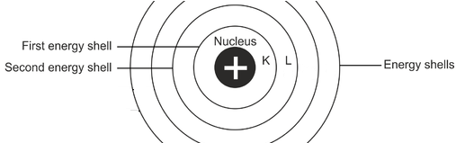
Explain why the decay of Argon can produce two different energy X-rays.
Electrons can be captured from either the first or the second energy shell; because the first and second energy shells have electrons with different energies, the photon that is emitted in the beta capture has different energies depending on which shell the electron originated from.

- Calibration of the detector requires determining how it responds to a variety of different energy depositions. Suggest reasons why Ar-37 was chosen as a calibration source.
Ar-37 produces X-rays with very specific energies so calibration can be done precisely. In addition, because Ar-37 emits two different X-rays the results of these two photons can be used to interpolate and extrapolate the detectors response based on a linear fit.

- Neutron calibration is done using a Beryllium-Americium source. The production of neutrons occurs through a two-step process.
  - In the first step, Americium-241 decays into Neptunium. Write the decay reaction for this reaction.

  - In the second step, Beryllium-9 reacts with the biproduct of the first reaction to produce a neutron and another isotope. Write the decay reaction and identify the new isotope produced.

- The diagram below visualizes how a Townsend Avalanche can occur.
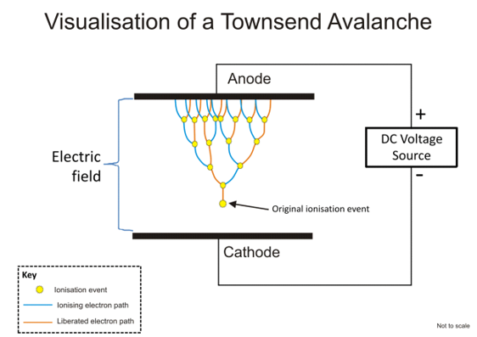
In this process, the original electron must gain sufficient energy to ionize a subsequent electron. In NEWS-G explain where the initial electron gains energy from. Why is this Avalanche unlikely to occur in high pressure gasses? In a high-pressure gas, an electron produced will only travel a short distance before interacting with another atom. The distance traveled will be too short for the electron to gain sufficient energy to ionize the atom; instead it will either scatter off the atom or create a photoelectric interaction.

The ionization energy of Neon (the primary gas used in NEWS-G) is 21.56 eV. Explain why the required voltage to start a Townsend Avalanche is dozens of times higher than 21.56 V. To ionize the atom, each collision will require 21.56 eV. If the original electron collides dozens of times, it wi

- Use the previous diagram of a Townsend Avalanche to answer the next two questions.
- Indicate the direction of the electric field between the Anode and Cathode.
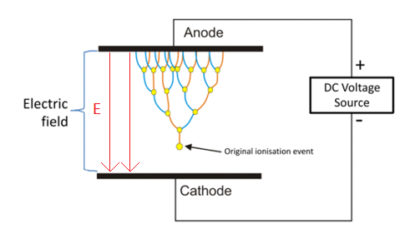
- In NEWS-G a Townsend Avalanche can occur within a few millimeters of the anode. If such an avalanche involves the original electron undergoing 8 collisions, how many electrons should reach the anode?

Modeling the Detector
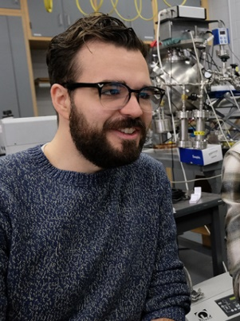
In addition to calibrating the detector using radioactive isotopes, computer simulations are also used to model the understanding of the how the detector functions. Daniel Dunford is a graduate student at the U of A who has worked to calibrate NEWS-G by modeling the motion of the electron as it moves through the sphere.
- The diagram below shows the detector data in blue and the computer simulation in red.
- Compare the detector data with the computer simulation. What factors could influence the time an electron takes from ionization to reach the anode?
Potential difference, gas pressure, number of collisions, shell (K or L) that produced the electron.

- Look at the plot near 2800 eV. What are some possible reasons for the disagreement between the model and the observations?
Collisions between electrons and atoms are random, (others?)
- What is the benefit of a theoretical model and observational data when calibrating NEWS-G?
Accurate models demonstrate a good understanding of the physics behind the detector. They allow predictions to be made and then checked against experiments. If the model fits observations well, the model can be used to make predictions for regions outside the calibration energies used.

- Scientific investigations usually involve both observational (empirical) data and theoretical models. Both are essential to developing a complete understanding of a phenomenon. Explain how scientists develop these two lines of evidence and what types of uncertainties may exist in each.
Answers may vary. Possible answers are below:
Empirical data is developed observations and experimentation and are limited by the precision and accuracy of the measuring device.
Theoretical data is developed using our understand of Physical Laws and applying them to the experiment.

