Current Carrying Wires
In 1820 Hans Orsted observed that compass needles deflected from magnetic North when placed near a current carrying wire.

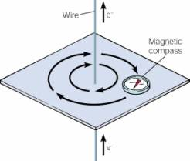
He mapped out the magnetic field using small compasses and found that the field formed concentric circles.
The direction of the magnetic field is predicted by the 1st Left/Right Hand Rule.
You thumb indicates the direction current is flowing while your fingers show the direction of the magnetic field.

If a current carrying wire is placed inside a magnetic field it will experience a Magnetic Force. This is because the wire itself can be thought of as a stream of charged particles all traveling in a straight line.
Current is the charge that passes through a wire in a certain amount of time. Mathematically it is expressed as:
I = Current (A)
q = Charge (C)
t = time (s)

$$I=\frac{q}{t}$$

Example 1:
A typical light bulb draws 4.5 A of current. Determine the amount of charge that pass through the light bulb in 5.0 min.

Using the equation of Current, Loretnz Force (F_{m} = qvB) and average velocity (v = d/t) derive an expression for the Magnetic Force on a length of current carrying wire.

Example 2:
A copper wire carries a current of 12.5 A perpendicular through a 0.065 T magnetic field. If the wire experiences a 0.350 N force, what is the length of the wire?

Example 3:
A wire carrying 2.5 A of current is placed in a magnetic field. If the wire is 2.5 m long and has a mass of 200 g what is the Magnetic Field strength that would allow the magnetic and gravitational forces to balance?

Example 4:
4.5 x 10²⁰ electrons pass a point on the wires below in 60 s. If the magnetic field strength is 0.33 T, determine the net magnetic force acting on the section of wire:

Electric Motors & Generators

An electric motor requires several key pieces. Identify the purpose of each of the parts below.
Permanent Magnet:

Coils of wire

Axle

Commutator

Brushes

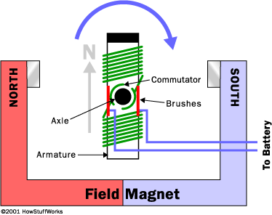

Use the diagram above to answer the next question.
- Explain why electric motors must have a commutator to function properly. If they lacked a commutator what would happen?

The QR code is the link for the youtube video watched in class.

Electric Generators
A motor coverts electrical energy into kinetic energy. An electric generator does the opposite; it converts kinetic energy into electrical energy.
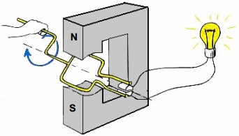
By moving a coil of wire inside a magnetic field, electrons can be made to move through the wire. In fact, any time a loop of wire experiences a changing magnetic field, current will be induced in the wire.
- Indicate the direction of the magnetic field in the diagram.
- Explain how the magnetic field through the loop changes even though the magnet is not moving.
Extensions:
- Feel like building your own electric motor?
- What factors influence the amount of power an electric generator produces?
- Where does the energy to turn the coil of an electric generator come from?

