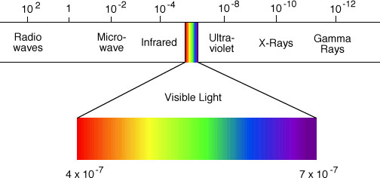

Physics 30

Unit C

Electromagnetic Radiation

Examples and Practice Questions

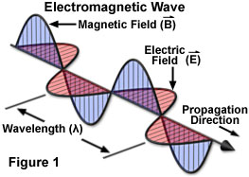

**Lesson 1: Introduction to Electromagnetic Radiation**

1. Define:
   1. Wavelength
   2. Amplitude
   3. Frequency
   4. Period
   5. Medium
   6. Propagation
2. What is the frequency of light that has wavelength of 169 nm?
3. A radio wave is a form of EMR. Determine the wavelength of 103.9 FM. (f = 103.9 MHz)
4. High energy helium-neon lasers have a wavelength of 632.8 nm and a frequency of 4.74 x 1014 Hz. What is the speed of light they emit?

**Lesson 2: The Speed of Light**

1. The New Horizons Space Craft passed Pluto on July 14th, 2015. The distance between Pluto and the Earth was 4,700,000,000 km. How long do Scientists have to wait for radio signals from the space craft to reach Earth?
2. Michelson used an 8-sided mirror rotating at 495 Hz with a stationary mirror placed 35.5 km away.
   1. What value for *c* did he get?
   2. What was his percent error?
3. The speed of light in water is 2.26 x 108 m/s. A 6 sided rotating mirror is placed 15.0 km from a stationary mirror. What would you expect the mirror to rotate at to measure the speed of light?
4. Mr. Doktor wants to measure the speed of light in the classroom using a Michelson type experiment. Estimate the maximum baseline possible in the classroom and use this to determine the necessary rotation rate for an 8 sided mirror. How could this speed be decreased?

**Lesson 3: Refraction of Light**

1. What angle from the normal does the light reflect off mirror B in the diagram below?



1. What is the speed of light in diamond?

v1 = 3.00 x 108 m/s n1 = 1.00

n2 = 2.42

1. What is the angle of refraction and speed of light in water if the incident angle in air is 40.00?



1. When light passes into a crystal from air its speed is 2.36 x 108 m/s. Determine the index of refraction of the crystal.
2. Light with a wavelength of 450 nm from air strikes the surface of glass (n = 1.54).
   1. Determine the frequency of light in the glass.
   2. Determine the wavelength of light in the glass
3. A light ray enters a flint glass prism from air (n=1.61) from the air as shown in the diagram. Trace the light’s path and find the angle that it leaves the prism at.



1. When light passes from air into glass it refracts. The incident and refracted angles of a glass block were measured. Use the data to determine the index of refraction

|  |  |  |  |
| --- | --- | --- | --- |
| θi | θf | sinθi | sinθf |
| 10.0 | 6.88 |  |  |
| 15.0 | 10.3 |  |  |
| 20.0 | 13.6 |  |  |
| 25.0 | 17.2 |  |  |
| 30.0 | 20.2 |  |  |

**Lesson 4: Critical Angles**

1. What is the critical angle of a substance that has an index of refraction is 1.55? (θ2 = 900)
2. The speed of light in a certain oil is 1/3 what it is in air. What is the critical angle of the liquid?
3. What is the frequency of light in ice (n=1.31) if the frequency in diamond (n=2.42) is 5.55 x 1014 Hz?
4. A light ray strikes a prism at 10o to the normal as shown below. Determine the angle that it leaves the prism at.

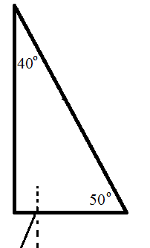

1. A beam of light contains both red (n = 1.512) and blue (n = 1.524) light and travels through a 2.00 cm thick piece of crown glass and back into air. The beam strikes at a 25o incident angle.
   1. What angles do the two colours emerge at?
   2. What is the distance separating the two colours when they emerge?

**Lesson 5: Lenses**

1. Draw the Ray Diagram.

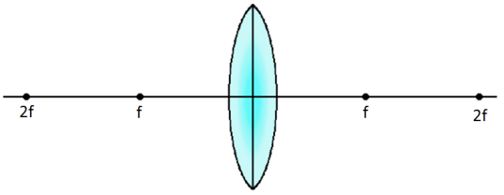

1. Draw the Ray Diagram.



1. Draw the Ray Diagram



1. Draw the Ray Diagram.



1. Draw the Ray Diagram.

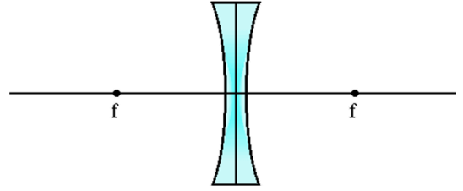

**Lesson 6: Thin Lens equation**

1. A converging lens has a focal length of 15 cm. If an object is placed 20 cm away from the lens where will the image form?
2. A candle 2.5 cm tall is placed in front of a converging lens. A virtual image is formed 30 cm away from the lens. If the image has a height of 4.5 cm determine the focal length.
3. A tree with a height of 2.50 m is viewed through a pair of binoculars. The image has a height of -3.00 m when the object is 11.0 m away.
   1. Determine the focal length of the binoculars.
   2. Is this a converging or diverging lens?
4. A macro camera lens is used to take close-up photographs.
   1. If the lens has a focal length of 21 mm and the farthest it can be placed from the film is 31 mm, determine the closest that an object can be placed if it is to be photographed.
   2. What is the magnification of the object?
5. In a simple lens experiment students measured the distance of a lens to an object and the recorded the location of where the image formed. The results are shown in the table. Use this information to determine the focal length of the lens.

|  |  |  |  |
| --- | --- | --- | --- |
| Object Distance (cm) | Image Distance (cm) |  |  |
| 15.0 | 58.0 |  |  |
| 20.0 | 31.0 |  |  |
| 25.0 | 22.5 |  |  |
| 30.0 | 20.0 |  |  |
| 35.0 | 17.5 |  |  |
| 40.0 | 17.2 |  |  |

**Lesson 7: Curved Mirrors**

1. Draw the Ray Diagram

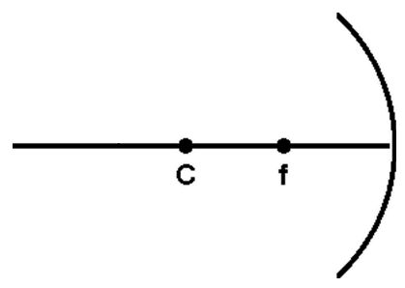

1. Draw the Ray Diagram



1. Draw the Ray Diagram



1. Draw the Ray Diagram



1. Draw the Ray Diagram



1. Draw the Ray Diagram

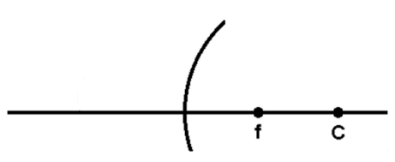

1. A concave lens has a focal length of +20 cm. Determine where the image will be formed when an object is placed 28 cm from the mirror. What will the magnification be?
2. A converging lens has a focal length of +18 cm. Where will the image be formed when an object is placed 18 cm from the mirror?
3. Determine the focal length of a diverging mirror if an image is formed 12 cm from the mirror when an object is placed 25 cm away.
4. The image has a height of +5.0 cm. Determine the object’s height.
5. A telescope with a focal length of 1800 mm is pointed at the moon which is very far away. Where does the image form?
6. A candle with placed in front of a concave mirror with a focal length of 14.0 cm. A real image forms 18.5 cm away from the mirror with a height of 4.5 cm. Determine the height of the candle.

**Lesson 8: Diffraction & Interference**

1. Monochromatic light falls on a diffraction grating in which the slits are 5.45 x 10-6m apart. Calculate the wavelength of light if the 1st order maximum is produced at a 4.00o angle of deviation.
2. Monochromatic light has a frequency of 4.77 x 1014 Hz and is directed on a diffraction grating ruled with 3.98 x 104 lines/m. An interference pattern is produced on a screen 1.10 m from the grating. How far is the 1st order maximum from the central maximum?
3. A diffraction grating with 750 lines mm apart is used to produce a series of bright and dark spots. A red laser (λ = 648 nm) is used. How many bright fringes will be seen on each side of the grating?
4. A double slit is placed 85.0 cm from a screen. The 2nd order minimum is observed to be 55.0 cm from the central maximum when yellow light (565 nm) is used. How far apart are the slits?
5. X-Rays with a wavelength of 6.80 x 10-12 m are used to determine the structure of DNA. If bright spots are observed 0.040 m apart on a screen 2.00 m from a DNA sample determine the spacing of the Base Pairs.

**Lesson 9: Particle Model of Light**

1. A visible light photon carries approximately 2.0 eV of energy. Determine the frequency and wavelength of this photon.
2. Ultraviolet light at 290 nm can penetrate tissue into the chromosomes and damage DNA. How much energy (in eV) does one photon carry?
3. A photon from the sun carries 1.04 x 10-18 J of energy. Determine the wavelength of the photon.
4. A 3.0 mW Helium-Neon Laser has a frequency of 520 THz.
   1. Determine the energy of one photon from this laser.
   2. A typical photon from a 100 W light bulb has a frequency of 3.5 x 1014 Hz. Determine the energy of one photon from the light bulb.
   3. Using your results explain how the light bulb emits more energy.
   4. Determine the number of photons emitted from the laser and the bulb each second.
5. The NOW Radio Station broadcasts at 102.3 MHz with a power output of 100 kW.
   1. What is the wavelength of the radio waves emitted?
   2. What is the energy of 1 photon?
   3. How many photons are emitted during a 3.0 minute song?

**Lesson 10: Photoelectric Effect**

1. The work function of the sensor in a particular cell phone camera is 1.7 eV. Determine the minimum wavelength of light needed to record the photon.
2. Light with a wavelength of 425 nm falls on a photoelectric metal with a work function of 2.0 eV.
   1. How much energy is carried away by an electron?
   2. What is the maximum speed of ejected electrons?
3. Electrons are ejected from a gold surface with a maximum energy of 1.5 eV. If the photons of the incident light have energy of 3.45 eV what is the minimum frequency of the light that can be used?
4. A certain metal has a threshold frequency of 6.76 x 1014 Hz. Light of an unknown frequency shines on the metal and electrons are ejected with speed of 1.26 x 106 m/s. Determine the frequency of light.

**Lesson 11: Stopping Voltage**

1. A photoelectron is ejected with 4.5 eV of energy. Determine the voltage required to bring the electron to a stop.
2. Light with a wavelength of 450 nm strikes a metal surface with a work function of 1.9 eV.
   1. Determine the energy of the photoelectron.
   2. What is the required stopping voltage?
3. In a photoelectric cell the minimum voltage required to reduce current through the cell to zero is 3.0 V. What it he maximum velocity of the electrons ejected from the photoelectric cell?
4. In a photoelectric experiment using Cesium, Madison the Mighty Mathematician gathered the following data:

|  |  |
| --- | --- |
| Stopping Voltage (V) | Frequency of Light (x 1014 Hz) |
| 0.10 | 5.49 |
| 0.70 | 6.88 |
| 1.3 | 8.21 |
| 2.7 | 11.8 |

1. Graph the stopping Voltage vs frequency
2. Use the graph to determine the threshold frequency
3. Use the graph to determine Planck’s constant
4. Determine the work function of Cesium
5. Night vision goggles make use of the Photoelectric Effect and potential differences inside vacuum tubes (called Dynodes) that serves as an electron multiplier through the process of secondary emission. A photon strikes a photocathode and release an electron. The electron is accelerated across a number of Dynodes each with a potential difference of 100 V. As the electron strikes the next dynode, because of its increased energy, it causes more electrons to be released.

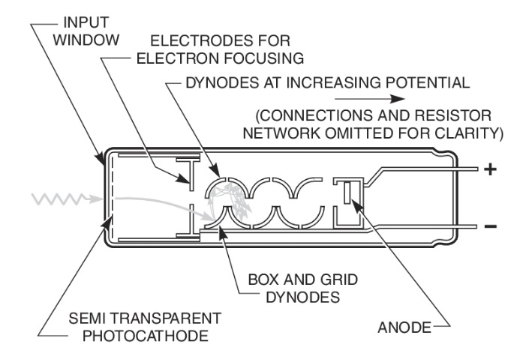

Each dynode is set at 100 V higher potential difference. An incoming photon with a wavelength of 465 nm strikes a photosensitive material with a work function of 1.80 x 10-19 J. An electron is emitted and travels into a photomultiplier tube with 10 dynodes.

1. What is the kinetic energy of the original photoelectron?
2. How much energy does each electron gain as it crosses each dynode?

**Lesson 12: X-Rays**

1. A typical dental X-ray has a wavelength of 0.020 nm.
   1. Determine the energy of the X-ray.
   2. What is the potential difference electrons must be accelerated across to produce these X-rays?
2. If the energy of a photon is 2.5 x 10-14 J what is its momentum?
3. If a photon has a momentum of 4.5 x 10-23 kg m/s what is its velocity?
4. How does the momentum of a photon that has a kinetic energy of 19.6 eV compare to an alpha particle that has a kinetic energy of 1.25 x 10-1 eV?
5. A 6.9 pm X-ray strikes a metal plate. Electrons are released and travel at a speed of1.03 x 108 m/s. Determine the wavelength of the scattered X-ray.

**Lesson 13: Compton Scattering**

1. Determine the change in wavelength if an X-ray is scattered by

a) 10o

b) 180o

1. An incident X-ray has 4.28 MeV of energy and is scattered by an electron. The electron gains 2.64 MeV of kinetic energy. What angle was the X-ray scattered across?
2. An X-ray with a wavelength of 3.5 x 10-15 m collides with a proton and is scattered at an angle of 30o. Determine:
   1. The change in wavelength of the photon.
   2. The kinetic energy of the Proton after the collision.
   3. The momentum of the proton after the collision.
   4. The velocity of the proton after the collision.
3. A space craft with a solar sail has a total mass of 1500 kg. Photons with a wavelength of 650 nm strike the sail and push the ship. The space ship increases its speed by 100 m/s.
   1. Determine the change in momentum of the spaceship.
   2. Determine the momentum of one photon that strikes the sail.
   3. How many photons must strike the sail to change its velocity by 100 m/s?
   4. How could you increase the change in velocity?

**Lesson 14: Matter Waves**

1. What is the wavelength of an electron moving at 3.5 x 107 m/s?
2. Determine your de Broglie wavelength if you run at 10 m/s. Compare that to the wavelength of a proton moving 2.5 x 104 m/s.
3. What is the wavelength of an electron with a kinetic energy of 35 eV?
4. An electron is accelerated through a potential difference of 75000 V. Determine its deBroglie wavelength.