**Activity 3: Piezoelectric Detection**

**Background**

PICASSO is a bubble chamber that has been used in the search for dark matter. It is designed to detect the interaction of dark matter particles with droplets of Perflubutane (C4F10). These droplets are held in a metastable superheated state and undergo rapid nucleation (they turn to a gas) when a dark matter (or other subatomic) particle interacts with them. The phase change produces a bubble that is detected both visually and through piezoelectric sensors that measure audible signals.

Piezoelectric materials produce an electrical charge when they are subjected to mechanical stress. The pressure change induced by the nucleation of a bubble in PICASSO creates a change in voltage in the piezoelectric material that is read by scientists in their search of dark matter. The video below shows this how a piezoelectric material produces charge as it vibrates.

[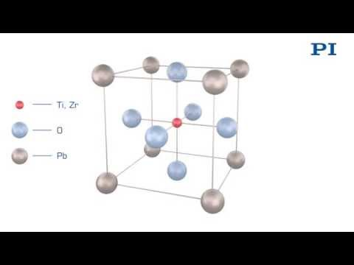](https://www.youtube.com/embed/y2pAFuSciB4?feature=oembed)

In one dimension, the vibrations of a piezo-electric material can be approximately modeled using Hooke’s Law:



Where *F* is the force applied to the material (N), *k* is the piezoelectric constant (N/m), and *x* is the amount of compression on extension of the material from its equilibrium state (m).

Each piezoelectric material has a natural resonant frequency which causes the material to undergo a simple harmonic vibration.

Where F is the force applied to the material by the sound wave, *k* is the piezo-stiffness (in 1 dimension it is analogous to the spring constant) and *x* is the displacement of the material by the sound wave.

The resonant frequency can be determined using the:



Where:  
*fo* = resonant frequency (Hz)

k = piezo stiffness (N/m)

m = vibrating mass of piezoelectric material (kg)

**Activity**

During a data run, one of the piezoelectric sensors records a sound wave caused by a nucleation event. The graph of the reading from the sensor is shown below.

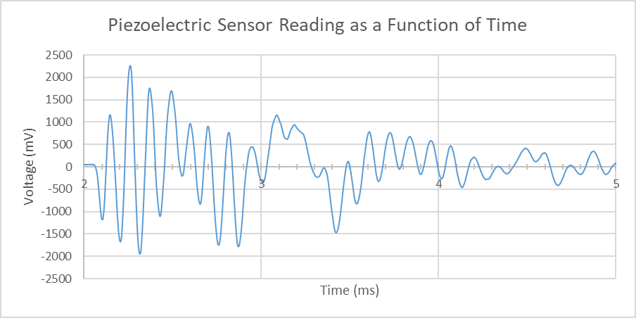

1. Using the graph of the corrected signal, determine the frequency of the piezo vibration.

Approximately 0.10 ms – 0.20 ms

1. What is the period of this vibration? *Double check your units!*



1. The effective mass of the piezoelectric sensors on PICASSO is 120 g. Use this to determine the spring (piezoelectric) constant.





1. If the piezoelectric material is compressed a maximum 3.5 μm as sound wave strikes it, determine the maximum force being applied to it.



1. Determine the maximum acceleration of the piezoelectric sensor.



1. During this compression, determine the amount of work done of the piezoelectric sensor.

 

1. What is the maximum speed of the edge of the piezoelectric sensor could move at?

