Activity 3: Mass of Galaxies

Background

Measuring the mass of spiral galaxies can be done in two different, independent methods. The first is by looking at the brightness of the galaxy and the second is using the rotation rates of objects in the galaxy.

Method 1: The Brightness Method

In the brightness method astronomers assume that galaxies that emit more light have more stars in them and will be more massive. The brightness of a galaxy is measured in Luminosity and can be converted into kilograms by using the ratio of the Sun’s mass to light ratio and dividing the mass of the galaxy by this ratio.

- M_{enclosed} = (Luminosity) x 5133 kg/W

Problems

The images below show the Triangulum Galaxy (M33). Each circle encloses all the stars of a given radius. The radius of the circle and luminosity is given next to the image.

Image | Radius (m) | Enclosed Luminosity (Lx)
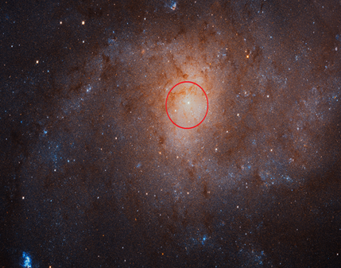 | 3.09 x 10¹⁹ | 3.18 x 10³⁵
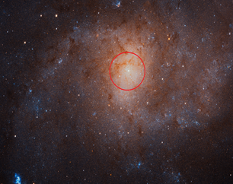 | 6.17 x 10¹⁹ | 5.73 x 10³⁵
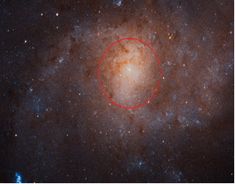 | 9.26 x 10¹⁹ | 7.70 x 10³⁵
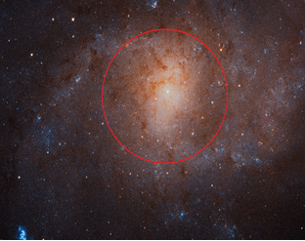 | 1.23 x10²⁰ | 9.20 x 10³⁵
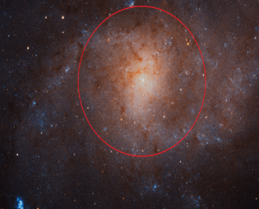 | 1.54 x 10²⁰ | 1.02 x 10³⁶
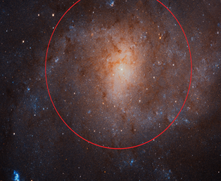 | 1.85 x 10²⁰ | 1.10 x 10³⁵
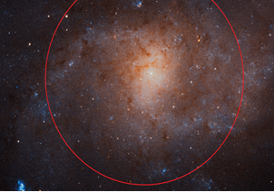 | 2.16 x 10²⁰ | 1.14 x 10³⁶
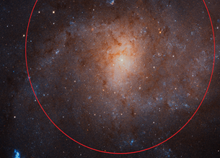 | 2.47 x 10²⁰ | 1.16 x 10³⁶
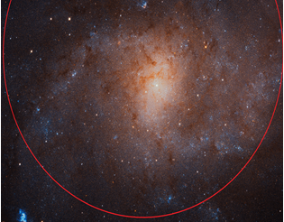 | 2.78 x 10²⁰ | 1.17 x 10³⁶

- Using the equation (1), convert the luminosity inside each circle into mass in kilograms.

- Plot the mass of the galaxy as a function of distance from the center of the galaxy.

- Describe the how the luminous mass of a galaxy changes with distance from the center.

- Using the last image, approximate the total luminous mass of M33.

Method 2: Orbital Velocity Method

The second method uses the same approach used to find the mass of Sun. Activity one showed how the mass of the Sun can be calculated by measuring the orbital velocity and orbital radius of the planets (as well as comets and asteroids). This approach can also be applied to the orbital motion of stars, gas clouds and globular clusters as they travel around spiral galaxies. However, because the stars (and therefore the mass) of a spiral galaxy is higher in the bulge of the galaxy and then spread out across tens of thousands light years, near the center of the galaxy stars orbital velocity will increase as orbital radius increases.

Outside the galactic bulge, the orbital velocity should be related to orbital radius according to Newton’s Law of Universal Gravity:
(1)

As a result, at larger and larger distances from the center of the galaxy, the orbital velocity of stars, gas clouds and globular clusters should decrease according to the plot below:
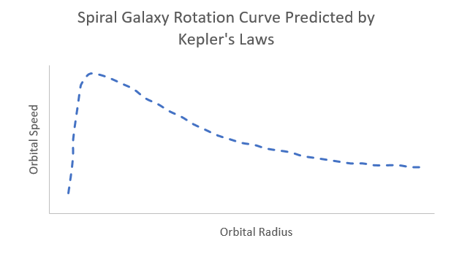
Figure 1: Orbital Speed vs Orbital Radius Predicted by Kepler’s Laws for Spiral Galaxies

The Triangulum Galaxy (M-33) is approximate 2.75 million light years from Earth and detailed measurements of the orbital motions of stars, globular clusters and gas clouds have been made by astronomers. Some of these observations are shown in the table below.

Orbital Radius of Star, Gas Cloud or Globular Cluster (x 10¹⁹ m) | Observed Speed  (km/s)
2.31 | 36.0
3.09 | 54.2
3.87 | 69.3
6.17 | 88.3
7.71 | 96.2
9.26 | 98.6
15.4 | 101.2
24.7 | 104.9
40.1 | 116.4

Problems
            - Create a plot showing the observed rotational speed vs orbital radius from the data from the Triangulum Galaxy.

            - Compare the plot to the prediction shown in Figure 1. Measurements of speed and distance are usually accurate to within 15%. Does the data fall within the measured uncertainty?
            - Using the orbital radius and speed of the outermost objects in the table calculate the mass of M-33.

            - Compare the mass found using the orbital velocity method to the brightness method.

            - Suggest a possible reason for the difference in the mass. (Hint: Recall that gravity is pulling stars and gas in their orbits around the center of the galaxy. The observed speed is much faster than predicted based on the visible mass).

