Force vs Displacement Graphs
- A 5.0 kg cart is pushed along a straight line by a force shown in the graph below. The object is at rest at t = 0 s and d = 0 m. 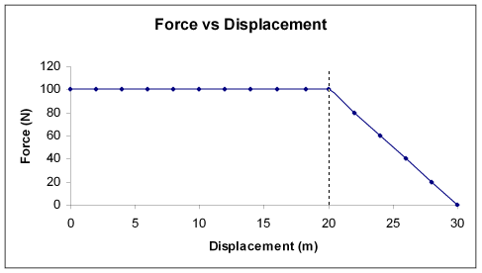
  - During what displacement is the cart’s acceleration constant?

  - What was the cart acceleration at d = 10 m?

  - How much work was done on the cart during the first 20 m?

  - How much time was required for the cart to move 20 m?

  - How much work was done moving the cart from d = 20 m to d = 30 m?

  - What was the total amount of work done?

- A 2.5 kg skateboard is pushed by forces as shown in the graph. At t = 0 the velocity is 0 m/s.
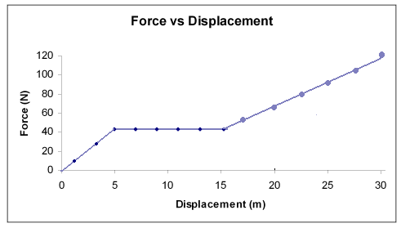
  - Determine the acceleration of the skate board at d = 10 m.

  - Where does the skateboard have the highest acceleration? What is the magnitude of the acceleration at this point?

  - Determine the amount of work done moving the skateboard from d = 0 m to d = 5 m.

  - Determine the amount of work done moving the skateboard from d = 5 m to d = 15 m.

  - Determine the amount of work done moving the skateboard from d = 15 m to d = 30 m.

  - What is the total amount of work done on the skateboard?

