Activity 1: SNOLAB
Teacher notes:
- The first question of this activity is designed for students to conduct research using the SNOLAB website or other online resources. Possible answers are provided in the key but there are many other descriptions that students may include.
- The second question uses the context of Dark Matter to ask students to explain the necessity for multiple lines of converging evidence in science before firm conclusions are made. The intended outcome is for students to understand that strong evidence in science is often an intersection of several different lines of evidence rather than the reliance on a single data point.
- The third and fourth question focus on the background signals detected by dark matter instruments. While there are specific background signals researchers focus on (mentioned in the answer key) the important outcome is for students to consider other sources of signals and suggest possible ways that experiments (any experiments) can be calibrated to include that information.

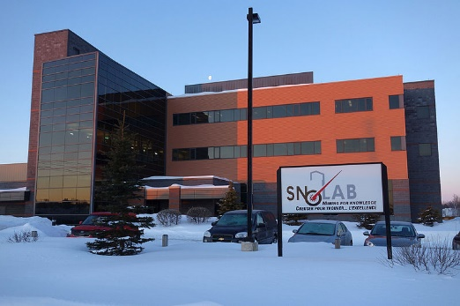
Found in Ontario, SNOLAB is ideally suited to search for dark matter particles. The laboratory itself is located beneath 2070 m of rock which act as an ideal shield for cosmic rays from outer space. The observatory has housed several ultra-sensitive experiments that search for Dark Matter and continues to provide an excellent location for on going dark matter research. Some of these experiments include:
- PICASSO (Project In Canada for Supersymmetric Objects)
- DEAP 3600
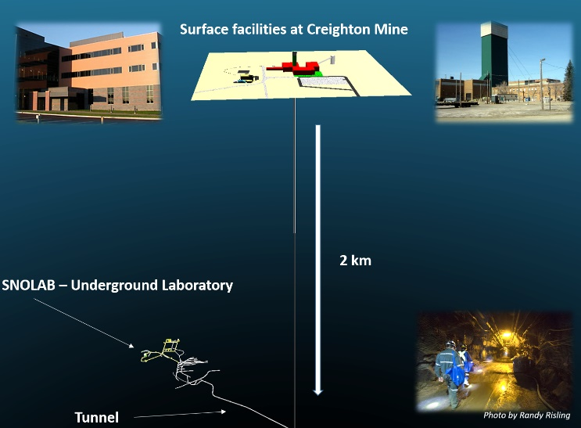
- NEWS-G
- Super CDMS

Activity:
- Choose one of the experiments from the list above (or a different Dark Matter experiment being conducted at SNOLAB). Using the information on the SNOLAB website (https://www.snolab.ca/science/experiments/) provide a summary of the experiment.
  - PICASSO (Project In Canada for Supersymmetric Objects)
PICASSO was an experimental bubble chamber designed with the intention of detecting dark matter. Central to the experiment was the possibility of Dark Matter particles colliding with the nucleus of a Fluorine atom. When such a collision occurred, energy and momentum would be transferred to the Fluorine nucleus causing it to recoil. Fluorine was contained in superheated liquid C₄F₁₀, which was contained in 50-100 µm diameter droplets. Being superheated, the droplets were very unstable and when a dark matter interaction occurred, they would suddenly boil, causing both a visual and audible signal.

  - DEAP-3600
DEAP-3600 uses a 3600 kg of liquid argon to look for dark matter. When dark matter interacts with Argon it produces a flash of ultraviolet light. Sensors around the vessel containing the Argon then detect this ultraviolet flash. The light is analyzed by particle physicists as they attempt to determine what types of particles and interactions caused the flash.

  - NEWS-G
NEWS-G (new experiments with spheres – gas) makes use of a copper sphere which is filled with a noble gas as it searches for Dark Matter. When ionizing radiation (like Dark Matter) enters the sphere it causes ionization in the noble gas. At the same time, a high voltage is maintained across the sphere. This potential difference causes freed electrons to drift to the center of the sphere which creates a charge that can be measured by the detector.

  - Super CDMS
SuperCDMS uses crystals of silicon and germanium to detect dark matter. Dark matter particles deposit a small amount of energy as they pass through the crystals. This causes the crystals to vibrate and produce a signal that can be measured by electronic sensors that surround them. The crystals are arranged in towers which are monitored by sensitive electronics that carefully look for minute signals of dark matter interactions.

- Why is it beneficial and necessary to have multiple experiments searching for Dark Matter particles?
- Different experiments have different strengths and weaknesses.
- Limits the weaknesses of a single experiment
- Relies of the strengths of each experiment
- When independent results converge to a single result it improves confidence in the results
- Even inside SNOLAB’s clean room the detectors are subject to background signals caused by radiation that interfere with the detection of dark matter. What are some possible sources for this radiation? What are some ways researchers attempt to minimize it?
- Small amounts of radiation from outer space can still reach the detector
- Radioactive decay from rocks in the Earth (such as Uranium or Thorium) or gaseous Radon.
- Electronic noise
- Others?
- Understanding the background signal around the detectors is essential to the successful operation of dark matter detectors. Do you agree or disagree with this statement? Justify your response.
Possible justifications can include the fact that background radiation cannot be completely eliminated. Without understanding what a background signal looks like it may be easily confused for a dark matter signal.

