Physics 20
Pulleys
Part A: Pulleys without friction

- Determine the acceleration of each of the pulley systems below:
  - m_{a} = 2.0 kg, m_{b} = 5.0 kg
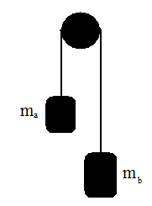
(4.2 m/s²)
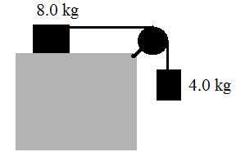

(3.3 m/s²)
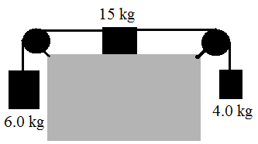

(0.78 m/s²)
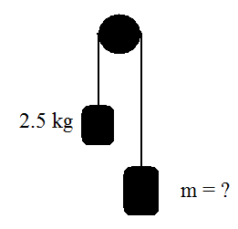
- If the pulley systems below accelerates at 1.0 m/s² in the clockwise direction determine the mass of the unknown block.

(3.1 kg)

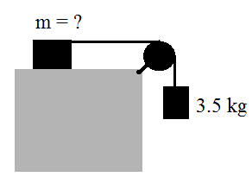

(31 kg)
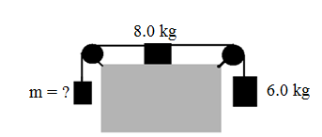

(4.1 kg)
- The pulley system below accelerates at 2.0 m/s² clockwise. If the mass of block A is 2.0 kg, what is the mass of block B?
(3.1 kg)

- Determine the acceleration of the pulley system below:
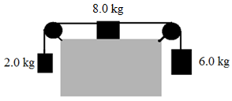

(2.5 m/s²)

