Activity 4: PICASSO and Energy Transfer
Background
PICASSO is a bubble chamber that has been used in the search for dark matter. The type of dark matter it is searching for is a weakly interactive massive particle, also known as a WIMP. It is designed to detect the interaction of dark matter particles with droplets of Perflubutane (C₄F₁₀). These droplets are held in a metastable, superheated state and undergo nucleation (they turn to a gas) when a dark matter (or other subatomic) particle interacts with them. The phase change produces a bubble that can be seen as well and detected through piezoelectric sensors that measures sound.
The detection of WIMPs depends on the momentum and energy transfers between the dark matter particles and the Fluorine atoms in the detector. The frequency of a WIMP interaction depends on how often dark matter particles collides with Fluorine in Perflubutane. This collision can be modeled as an elastic collision as shown in figure 1. In this diagram, a dark matter particle interacts with a nucleon in a Fluorine atom, causing the atoms to recoil.
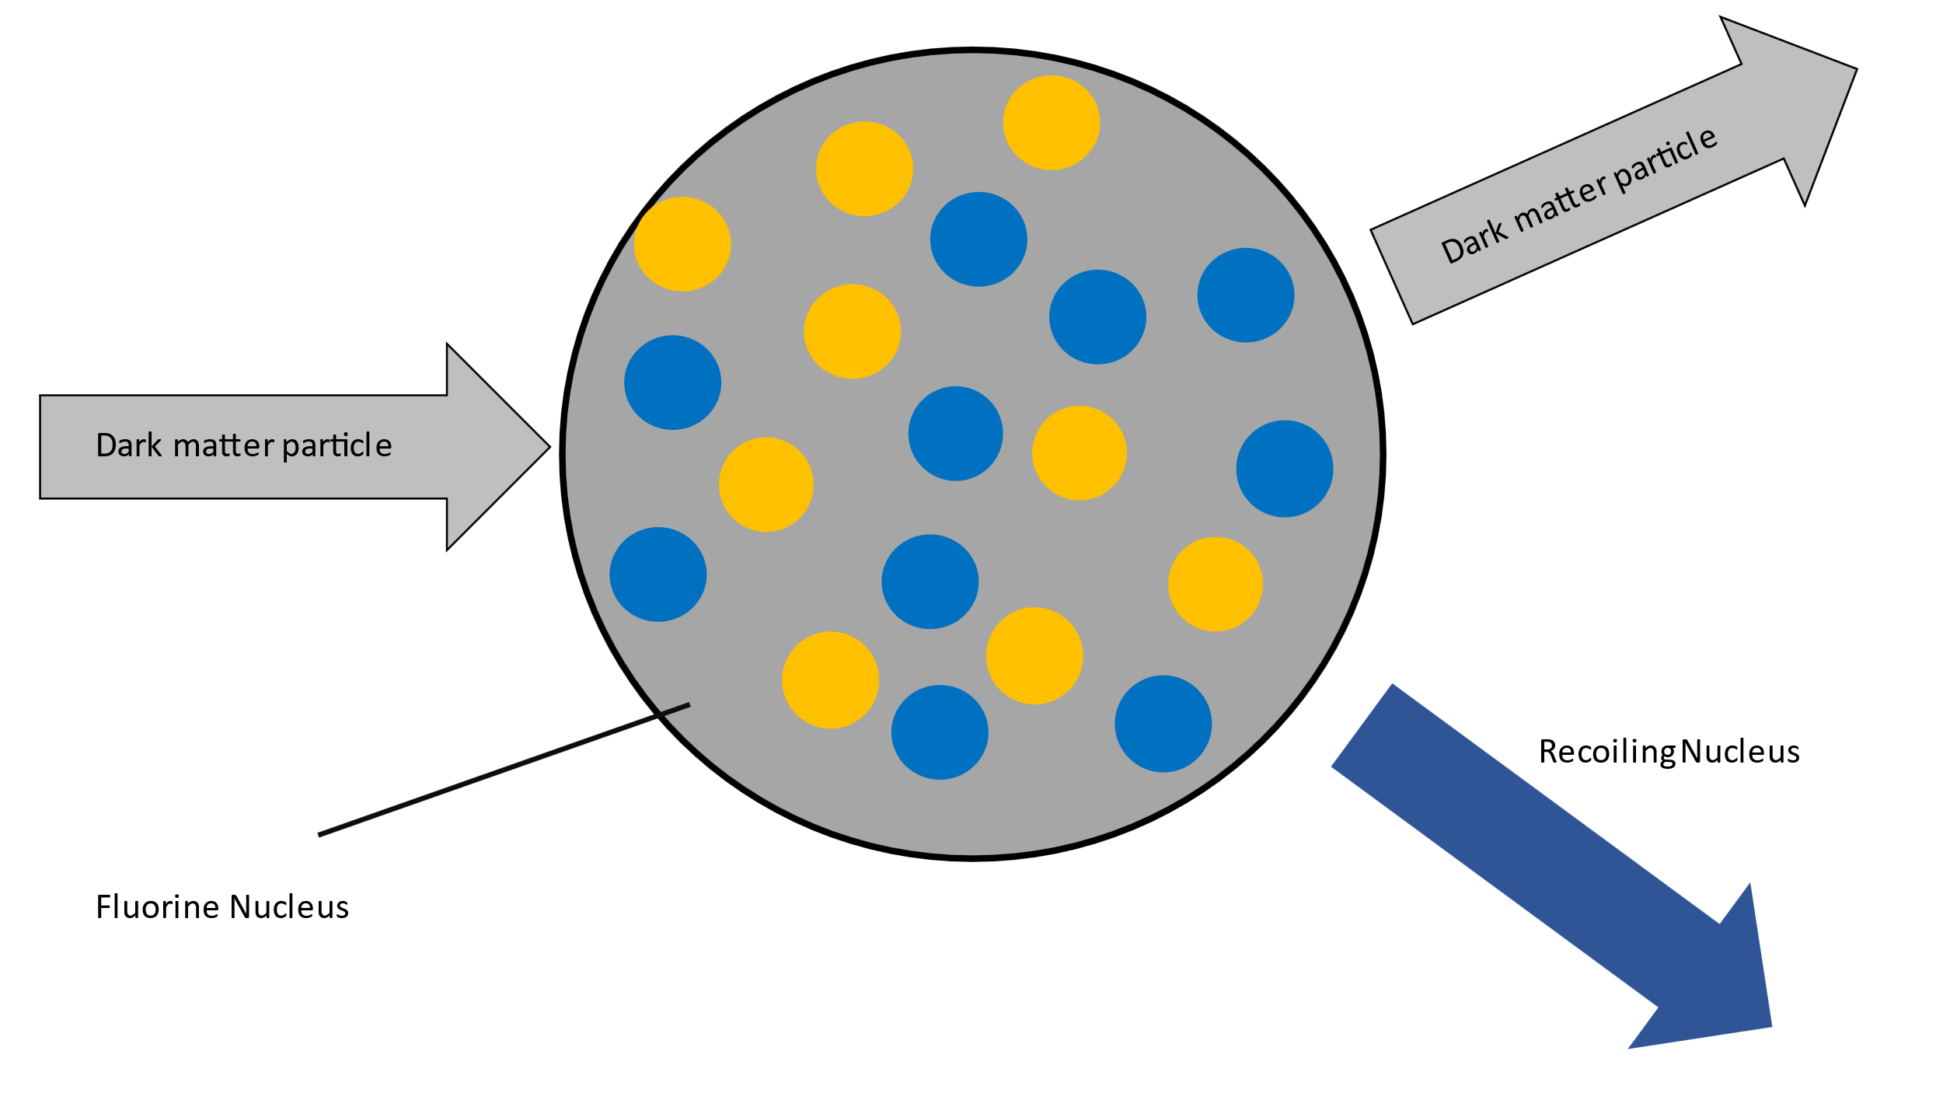
Figure 1: Elastic collision between dark matter and a nucleon in a Fluorine nucleus
The probability of a nuclear reaction occurring is described by the nuclear cross section. Particles with larger cross sections are more likely to interact with other particles. The larger the cross section, the greater the likelihood of a particle interaction.

Activity
- Watch the video Dark Matter Recoil. Based on this video, explain how a nucleation event inside PICASSO may be evidence of WIMPs interacting with Fluorine. Suggest other possible causes of the nucleation in addition to WIMPs colliding with nuclei in the detector. What techniques might physicists use to isolate WIMP interactions from these events.

- The Sun is moving through dark matter in the Galactic Halo (that will pass through out detectors) with an average speed of approximately 245 km/s. A bubble can form in PICASSO when a Fluorine nucleus (18.9984u) gains 3.20 x 10⁻¹⁷ J of energy from a dark matter interaction.

The diagram below shows the recoil angle and velocity of a Fluorine atom during the formation of a bubble.

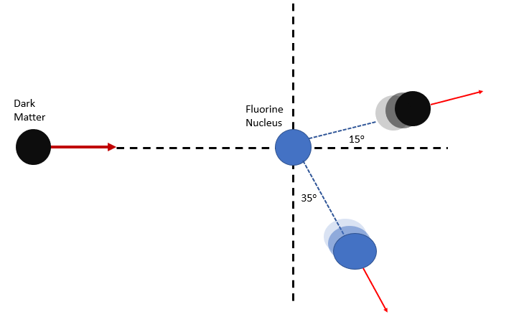
  - If a bubble forms, determine the recoil speed of the Fluorine nucleus.

  - Determine the momentum of the Fluorine nucleus as it recoils. Find the x- and y- components of this momentum.
  - If the dark matter particle recoils at 15º determine the ratio of the momentum in the x-direction to the momentum in the y-direction.

  - Using the mass of the dark matter particle as m_{D}, v_{x}’ as the velocity in the x-direction after the collision and v_{y}’ as the velocity in the y-direction after the collision write equations that represents the momentum of the system in both the x and y directions.

  - Using the equation from part c. and the two equations from part d., determine the mass of the dark matter particle (hint: solve the system of equations).

- Several detectors are being used to search for Dark Matter, each with different target mediums. Fluorine was chosen for PICASSO (m = 18.9984u) instead gases such as Xenon (m = 131.293u) which can be easier to work with. Discuss reasons why a lighter nucleus would be preferable in a bubble chamber; refer to nuclear recoil, conservation of momentum and conservation of energy.

- As of 2021, dark matter detectors have not conclusively detected WIMPs. However, reasonable upper limits are approximately 5000 GeV/c². In a detector similar to PICASSO, a dark matter particle collides head on with a target nucleus that uses Xenon (m = 131.293u). The WIMP strikes a nucleus in the detector at 250 km/s and continues moving in the same direction at 238 km/s.
  - Determine the recoil velocity of the Xenon nucleus in this collision if it is struck by a WIMP at the upper mass limit.

  - Quantitatively demonstrate that this is an elastic collision.

  - A target nucleus with a smaller mass was used in a subsequent experiment. What effect would the nucleus’ recoil velocity change?

  - In an elastic collision, the total kinetic energy of the system is conserved. What is the proportional relationship between kinetic energy and velocity?

  - What effect would using a smaller target nucleus have on the energy gained by that nucleus during an elastic collision?

  - For nucleation to happen, bubble chambers rely on energy transferred to the target nucleus. How would using a lighter nucleus affect the sensitivity of bubble chambers?
The graph below shows the probability that a reaction will occur (called the particle cross section) as a function of the WIMP mass in the PICASSO detector. The blue line shows the limit for which the detector is sensitive to dark matter particles. The region above the curve represents masses which should cause a detectable signal in PICASSO. The region below the blue line represents a region where the dark matter particles either interact to infrequently to be detected or produces a signal that will be overwhelmed by background noise. As of 2021 no dark matter interactions have been conclusively found by PICASSO.
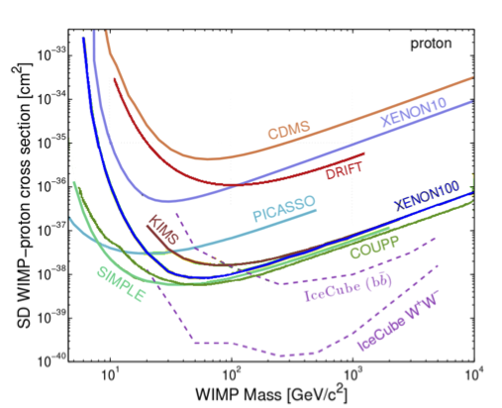
Is there a simple way to get this graph with only the PICASSO curve?

- Suggest reasons for the shape of the curve (why is the detector most sensitive to low mass WIMPs? Why does sensitivity increase as WIMP mass increase?)

- PICASSO uses superheated bubbles to search for WIMPs. Other experiments use crystals sensitive to vibrations or the ionization of electrons in atoms. Explain the scientific value of having several different types of detectors all searching for the same thing.

