**Activity 4: PICASSO and Energy Transfer**

**Background**

PICASSO is a bubble chamber that has been used in the search for dark matter. The type of dark matter it is searching for is a weakly interactive massive particle, also known as a WIMP. It is designed to detect the interaction of dark matter particles with droplets of Perflubutane (C4F10). These droplets are held in a metastable, superheated state and undergo nucleation (they turn to a gas) when a dark matter (or other subatomic) particle interacts with them. The phase change produces a bubble that can be seen as well and detected through piezoelectric sensors that measures sound.

The detection of WIMPs depends on the momentum and energy transfers between the dark matter particles and the Fluorine atoms in the detector. The frequency of a WIMP interaction depends on how often dark matter particles collides with Fluorine in Perflubutane. This collision can be modeled as an elastic collision as shown in figure 1. In this diagram, a dark matter particle interacts with a nucleon in a Fluorine atom, causing the atoms to recoil.

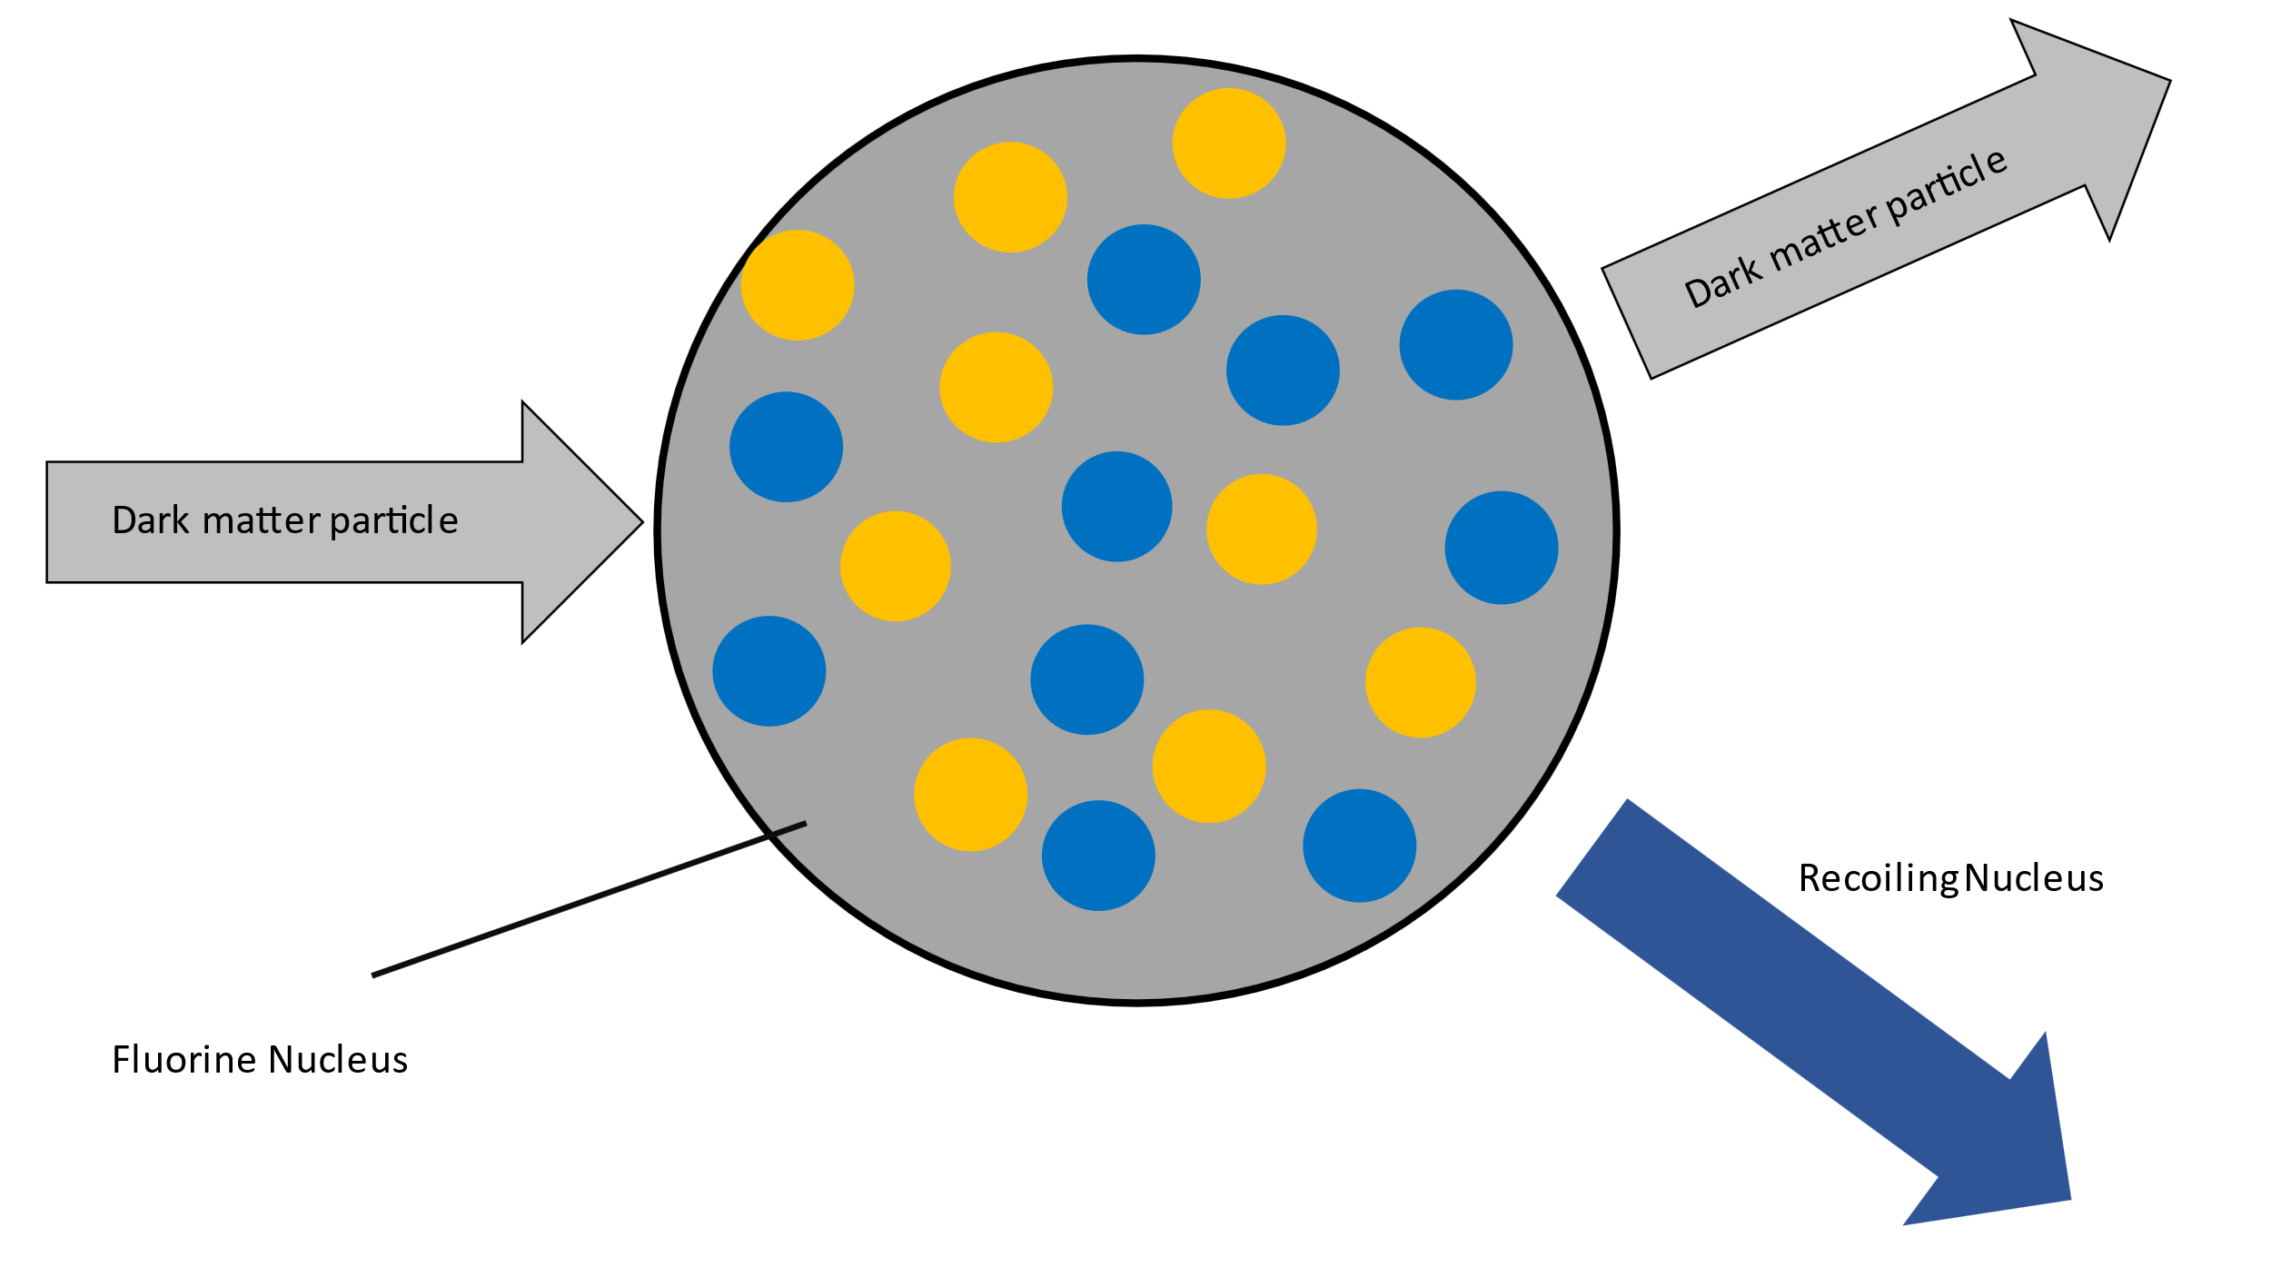

Figure 1: Elastic collision between dark matter and a nucleon in a Fluorine nucleus

The probability of a nuclear reaction occurring is described by the nuclear cross section. Particles with larger cross sections are more likely to interact with other particles. The larger the cross section, the greater the likelihood of a particle interaction.

**Activity**

1. Watch the video *Dark Matter Recoil*. Based on this video, explain how a nucleation event inside PICASSO may be evidence of WIMPs interacting with Fluorine. Suggest other possible causes of the nucleation in addition to WIMPs colliding with nuclei in the detector. What techniques might physicists use to isolate WIMP interactions from these events.

WIMPs can transfer energy and momentum to the Fluorine nucleus which causes it to recoil. As the nucleus recoils, the kinetic energy and momentum it has gained cause it to transfer energy to surrounding superheated material causing a nucleation event which forms the bubble detected in the sensor.

Nucleation events are caused by energy being transferred to the Fluorine nucleus in Perflubutane. That energy can come from many different sources in addition to WIMPs. Other subatomic particles such as alpha, beta, gamma, or neutron radiation carry energy and can cause nucleation. To avoid this unwanted nucleation the detector must be placed underground where the overbearing rock acts as a particle shield to limit the non-WIMP particles that pass through it.

1. The Sun is moving through dark matter in the Galactic Halo (that will pass through out detectors) with an average speed of approximately 245 km/s. A bubble can form in PICASSO when a Fluorine nucleus (18.9984*u*) gains 3.20 x 10-17 J of energy from a dark matter interaction.

The diagram below shows the recoil angle and velocity of a Fluorine atom during the formation of a bubble.

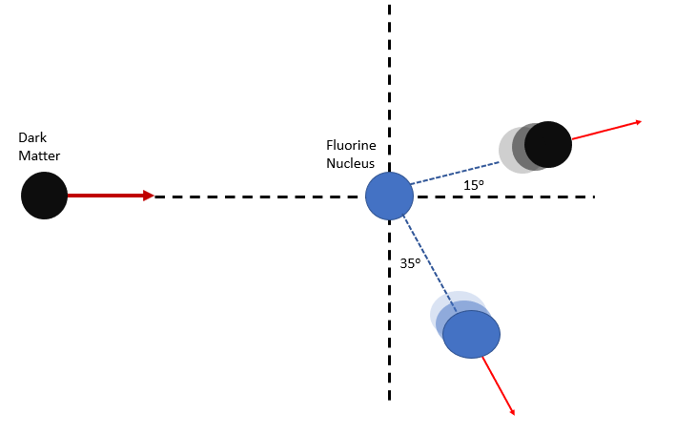

* 1. If a bubble forms, determine the recoil speed of the Fluorine nucleus.



* 1. Determine the momentum of the Fluorine nucleus as it recoils. Find the x- and y- components of this momentum.



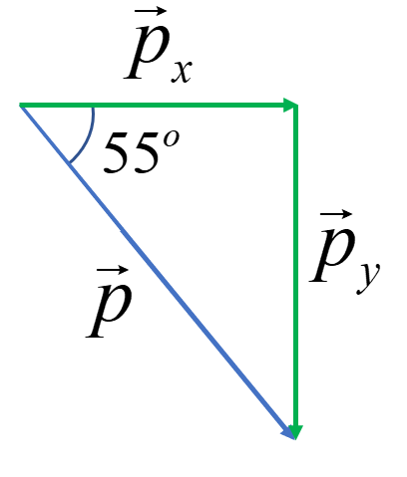





* 1. If the dark matter particle recoils at 15o determine the **ratio** of the momentum in the x-direction to the momentum in the y-direction.

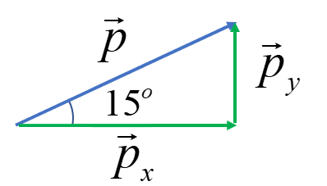



* 1. Using the mass of the dark matter particle as *mD*, *vx’* as the velocity in the x-direction after the collision and *vy’* as the velocity in the y-direction after the collision write equations that represents the conservation of momentum of the system in both the x and y directions.



* 1. Using the equation from part c. and the two equations from part d., determine the mass of the dark matter particle (*hint: solve the system of equations).* Determine the mass in kg, *u* and GeV/c2.

Equation 1: 

Equation 2: 

Equation 3: 

Equations 1 & 2



Equation 3 & 4



1. Several detectors are being used to search for Dark Matter, each with different target mediums. Fluorine was chosen for PICASSO (m = 18.9984*u*) instead gases such as Xenon (m = 131.293*u*) which can be easier to work with. Discuss reasons why a lighter nucleus would be preferable in a bubble chamber; refer to nuclear recoil, conservation of momentum and conservation of energy.

Lighter nuclei with lower masses will recoil faster and absorb a larger amount of kinetic energy. This will result in nucleation happening more often and with lower energies. This improves the sensitivity for dark matter that has lower energies and momenta.

1. As of 2021, dark matter detectors have not conclusively detected WIMPs. However, reasonable upper limits are approximately 5000 GeV/c2. In a detector similar to PICASSO, a dark matter particle collides head on with a target nucleus that uses Xenon (m = 131.293*u*). The WIMP strikes a nucleus in the detector at 250 km/s and continues moving in the same direction at 238 km/s.
   1. Determine the recoil velocity of the Xenon nucleus in this collision if it is struck by a WIMP at the upper mass limit.





Note: This question can also be solved using conservation of energy.



* 1. Quantitatively demonstrate that this is an elastic collision.

|  |  |
| --- | --- |
| Initial Momentum | Final Momentum |
|  |  |
| Initial Kinetic Energy | Final Kinetic Energy |
|  |  |

* 1. A target nucleus with a smaller mass was used in a subsequent experiment. What effect would the nucleus’ recoil velocity change?

A smaller nucleus would recoil at a higher speed and have greater kinetic energy.

* 1. In an elastic collision, the total kinetic energy of the system is conserved. If the recoil velocity increases by 20% by what percent does the kinetic energy increase by?



* 1. What effect would using a smaller target nucleus have on the energy gained by that nucleus during an elastic collision?

Using a smaller nucleus results in a larger recoil velocity of the nucleus. This causes the nucleus to gain more kinetic energy.

* 1. For nucleation to happen, bubble chambers rely on energy transferred to the target nucleus. How would using a lighter nucleus affect the sensitivity of bubble chambers?

Lighter nuclei recoil faster and with greater kinetic energy. This means they are more sensitive to low momentum/energy interactions and can cause bubbles to form from lower energy particles which increases their sensitivity to those particles.

The graph below shows the probability that a reaction will occur (called the particle cross section) as a function of the WIMP mass in the PICASSO detector. The blue line shows the sensitivity limit of the detector. The region above the curve represents masses and cross sections which should cause a detectable signal in PICASSO. The region below the blue line represents a region where the dark matter particles either interact to infrequently to be detected or produces a signal that will be overwhelmed by background noise. As of 2021 no dark matter interactions have been conclusively found by PICASSO.

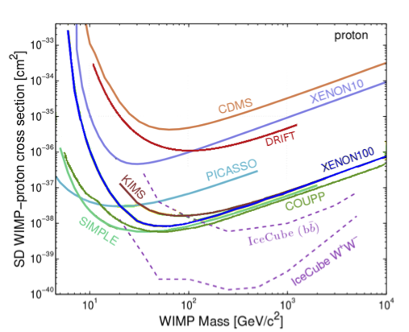

1. Suggest reasons for the shape of the curve (why is the detector most sensitive to low mass WIMPs? Why does sensitivity increase as WIMP mass increase?)

The galactic halo has approximately () mass of dark matter in it. If WIMPs have low mass that means there must be more, smaller particles to yield the necessary mass. If there are more particles, the probability of one of those particles interacting with the nucleus in a detector increases.

As the mass of WIMPs increase the detector can more easily detector those particles, although there may be fewer of them.

1. PICASSO uses superheated bubbles to search for WIMPs. Other experiments use crystals sensitive to vibrations or the ionization of electrons in atoms. Explain the scientific value of having several different types of detectors all searching for the same thing.

Using several different methods of detection allows to double check the results of each detector. Different detectors also rely on different physics and it is possible that the interaction required for one type of detector does not happen often when dark matter interacts. By using several different techniques researchers can avoid relying exclusively on one type of physics.